# Risk Assessment

| Date: | Assessed by: | Checked by: | Location: | Assessment ref no: | Review date: |
| --- | --- | --- | --- | --- | --- |
| Creation Care Champions Workshops in Church | | | | | |

| Activity | Hazard | Who might be harmed and how | Risk rating | Measures required to control risk (including existing measures) | Residual  Risk rating |
| --- | --- | --- | --- | --- | --- |
| Arrival at church | Trips and slips  Traffic | Children and adults | 4 | School staff will supervise children on arrival,.  Leader or volunteer to meet and greet and assist supervision of road crossing and guide them into the church. | 2 |
| Uneven floor | Trips and slips | Children and adults | 5 | Make sure everyone walks when inside the building.  Make adults aware of uneven floors.  First aid kit in church.  Enter any incidents in Accident Book .  Refer accidents to school staff. | 2 |
| Busy road outside | Traffic  Children leaving the group and wandering onto the road. | Children and adults | 5 | Gate will be closed.  Keep church doors closed while children are inside,  keep children closely supervised while outside. | 2 |
| Social media/photos without permission | GDPR issues  Safeguarding issues | Children and adults | 4 | School staff will know which children cannot appear on social media sites.  School staff only to take photographs of children.  Church can be sent photographs after the event. | 1 |
| Safeguarding issues | Disclosures  Members of the public entering the church or churchyard | Children and adults | 6 | Leader has current DBS check in place.  Volunteers have current DBS check in place.  More than one person at all times with the children, especially with regard to 1st Aid – Leader to offer 1st Aid Box and school staff to apply.  Enter any incidents in Accident Book. | 2 |
| Use of craft equipment – scissors, glue, small pieces etc. | Cuts | Children | 6 | Child-friendly blunt scissors (adults only to have pair of sharper scissors), child-friendly felt-tips etc; children supervised.  First aid kit on site.  Enter any incidents in Accident Book  First aid kit in church | 3 |
| Planting activities. | Hygiene | Children | 8 | Disposable gloves provided  Handwashing facilities/ hand sanitiser provided  Children to be briefed prior to touching compost/soil about not putting hands near mouths.  Children to be reminded not to put seeds into mouths. | 4 |
| Outdoor activities | Trips and slips  Danger from vegetation (stings and scratches) | Children and adults | 8 | Give clear parameters for where children should and should not go.  Make adults aware of trip hazards and rough ground.  First aid kit in church  Enter any incidents in Accident Book .  Refer accidents to school staff.. | 3 |

|  |  |  |  |
| --- | --- | --- | --- |
| Walking on footpaths  **Review of Risk Assessment (to be carried out before each occurrence of the activity)** | | | |
| **Date of activity** | **Detail of activity** | **Checked by** | **Signature** |
|  |  |  |  |
|  |  |  |  |
|  |  |  |  |
|  |  |  |  |
|  |  |  |  |
|  |  |  |  |
|  |  |  |  |
|  |  |  |  |

|  |  |  |  |  |
| --- | --- | --- | --- | --- |
| **Review of Risk Assessment (to be carried out before each occurrence of the activity)** | | | | |
| **Additional risk identified** | **Additional Control measures required** | **Action by whom** | **Action by when** | **Done** |
|  |  |  |  |  |
|  |  |  |  |  |
|  |  |  |  |  |

**Notes to accompany Example Risk Assessment Form**

**Important!**

**If you wish to use this assessment the identified hazards will only be adequately controlled if measures listed under ‘Existing measures to control risk’ are available and implemented, or where existing measures are equivalent to these or better**.

Action must be taken to address any deficiencies before this assessment can be regarded as suitable and sufficient for use (see 13).

**How to use the form for your situation**

1. **Date** : Insert date that assessment form is completed. It must be valid on that day
2. **Assessed by** : Insert the name and signature of the assessor. (Name is sufficient if done electronically)
3. **Checked / Validated* by** : delete one.

**Checked by** : Insert the name and signature of someone in a position to check that the assessment has been carried out by a competent person who can identify hazards and assess risk, and that the control measures are reasonable and in place. The checker will normally be a line manager, supervisor, principal investigator, etc. Checking will be appropriate for most risk assessments.

**Validated by**: Use this for higher risk scenarios, eg where complex calculations have to be validated by another “independent” person who is competent to do so, or where the control measure is a strict permit-to-work procedure requiring thorough preparation of a workplace. The validator should also have attended the University’s risk assessment course or equivalent, and will probably be a chartered engineer or professional with expertise in the task being considered. Examples of where validation is required include designs for pressure vessels, load-bearing equipment, lifting equipment carrying personnel or items over populated areas, and similar situations.

1. **Location**: insert details of where the assessment is intended to cover, e.g. building, floor, room, School, Directorate etc
2. **Assessment ref no**: insert any local tracking references used
3. **Review date**: insert details of when the assessment will be reviewed as a matter of routine. This might be in 1 year’s time, or a longer period if risks are known to be stable. Note that any assessment must be reviewed if there are any significant changes – to the work activity, the vicinity, the people exposed to the risk, etc
4. **Task / premises**:. This is a specific risk assessment for typical activities associated with work in an office environment
5. **Activity**: The rows in this column have been merged to indicate that all the hazards relate to the day to day work of the office environment being assessed.
6. **Hazard**: list all the hazards associated with the areas/tasks you want to use this assessment for. Remember to look at hazards that are not immediately obvious.

Remove any from and add others to the example assessment as necessary

1. **Persons in danger**: insert everyone who might be affected by the activity. Remember those who are not immediately involved in the work, including cleaners and maintenance contractors, Estates personnel carrying out routine maintenance and other work. Remember also that the risks for different groups will vary e.g. new and nursing mothers, disabled, young persons on work experience.
2. **Risk Rating**: this is a rating of the **remaining risk with the listed existing control measures in place** and is given as extreme, high, medium or low, depending on how likely the activity is to cause harm and how serious that harm might be.

**Important!** If this assessment is modified in any way users will need to check whether the given Risk Rating and Result are affected in any way and are still appropriate.

|  |  |  |  |  |  |  |  |  |
| --- | --- | --- | --- | --- | --- | --- | --- | --- |
| **Risk rating key** | | |  |  |  |  |  |  |
|  | | |  |  |  |  |  |  |
| **LIKELIHOOD (of consequence occurring)** | | | | | |
| 1 – VERY UNLIKELY | 2 - SLIGHT | 3 - FEASIBLE | 4 - LIKELY | 5 – ALMOST CERTAIN | 6 – CERTAIN OR HAPPENING |
|  | **IMPACT (of consequences)** | 5 – CRITICAL | 5 – MEDIUM | 10 - MEDIUM | 15 – HIGH | 20 - HIGH | 25 - HIGH | 30 - EXTREME |
|  | 4 – MAJOR | 4 – LOW | 8 - MEDIUM | 12 – MEDIUM | 16 - HIGH | 20 - HIGH | 24 – HIGH |
|  | 3 SIGNIFICANT | 3 – LOW | 6 - MEDIUM | 9 – MEDIUM | 12 - MEDIUM | 15 - HIGH | 18 - HIGH |
|  | 2 – MINOR | 2 – LOW | 4 – LOW | 6 – MEDIUM | 8 - MEDIUM | 10 - MEDIUM | 12 – MEDIUM |
|  | 1 - NEGLIGIBLE | 1 - LOW | 2 – LOW | 3 - LOW | 4 – LOW | 5 - MEDIUM | 6 – MEDIUM |

1. **Existing measures to control the risk**: The measures listed are those that are necessary to control the risks. Some specific hazards may require detailed assessments in accordance with specific legislation (eg, manual handling, DSE work,). Where this is the case, and a detailed assessment has already been done it is acceptable to cross reference this example risk assessment to the other documentation. Controls might also include use of qualified and/or experienced staff who are competent to carry out certain tasks; an action plan might include training requirements for other people who will be carrying out those tasks.

1. **Residual Risk Rating**: This is the assessed risk level once the proposed control measures have bene put in place. If this risk is still an A or B further consideration is essential before carrying out the activity.

**Severity Criteria**

Hazards have different implications depending on who is at risk (the target) therefore the severity criteria are different accordingly. Below is a framework to help you adapt your risk assessment according to who or what is at risk:

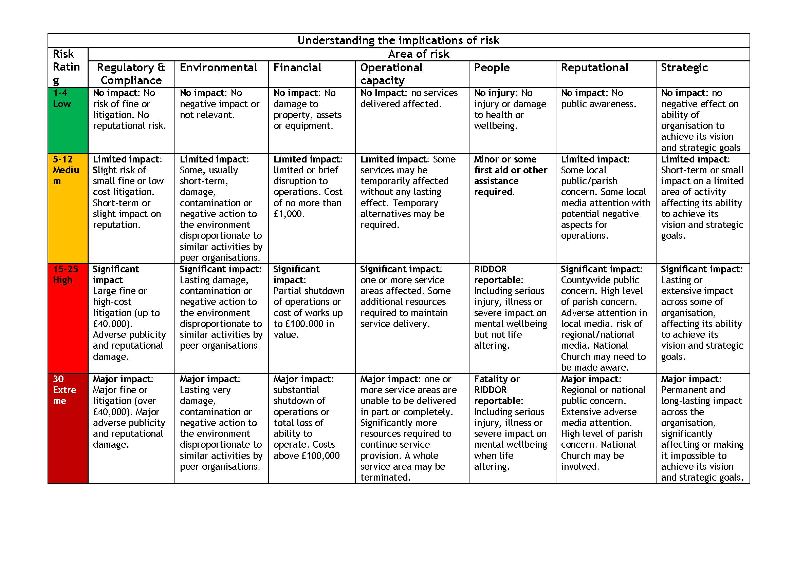

* RIDDOR reportable: mainly if serious injury that must be reported to Health and Safety Executive. For more details: <http://www.hse.gov.uk/riddor/reportable-incidents.htm>