This is a draft statement of commitment to equity, diversity and inclusion. You may wish to amend it to reflect your church. There are optional questions at the end to discuss, perhaps as part of a PCC meeting.

We have used the word equity rather than equality to reflect that people will all be at different starting points and to promote fairness, we must apply equitable processes to create an equality of outcome. For example:

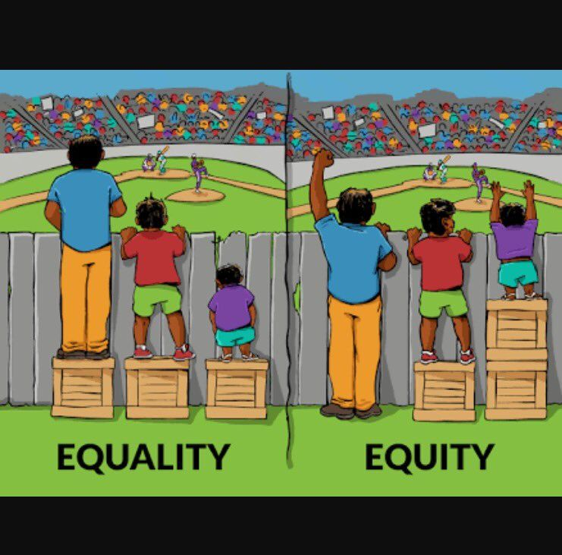

Our aim is to ensure that there is equity of opportunity for all church members, committee members and volunteers and that our organisation is representative of all sections of society.

We seek to respect and value each member to enable all to flourish. This policy reinforces our commitment to providing equity of opportunity and fairness to all in our members and not provide less favourable facilities or treatment on any ground.

We are opposed to all forms of unlawful and unfair discrimination. All members, no matter whether they are part-time, full-time, or temporary, paid or voluntary, will be treated fairly and with respect. When the clergy, officers and P.C.C. select and appoint candidates for specific roles and areas of responsibility they will do so on the basis of their aptitude and ability.

As a Church, we endeavour:

• To create an environment in which individual differences and the contributions of all members are recognised and valued.

• To create an environment that promotes dignity and respect for every member

• To not tolerate any form of intimidation, bullying, or harassment

• To promote equity in the workings and activities of the church

• To encourage anyone who feels they have been subject to discrimination to raise their concerns with the Vicar and Churchwardens in the first instance.

• To review regularly all our policies so that fairness is maintained at all times.

Think about how the following verses might apply in your community or Church:

**Proverbs 31:8** *“Speak up for people who cannot speak for themselves. Protect the rights of all who are helpless. Speak for them and be a righteous judge. Protect the rights of the poor and needy.”*

* Who are the people whose voices are unheard? How do you ensure they have an opportunity to be heard? If enabling them to be heard requires you to change your current practices, how do you feel about that?

**Proverbs 15:18** *Hot tempers bring arguments, but patience brings peace*

* Think about the issues on which you have strong opinions – how do you create space to listen to others’ opinions? How do you recognise the biases that may cause you to think the way you do? If agreement is not reached, how do you disagree well?