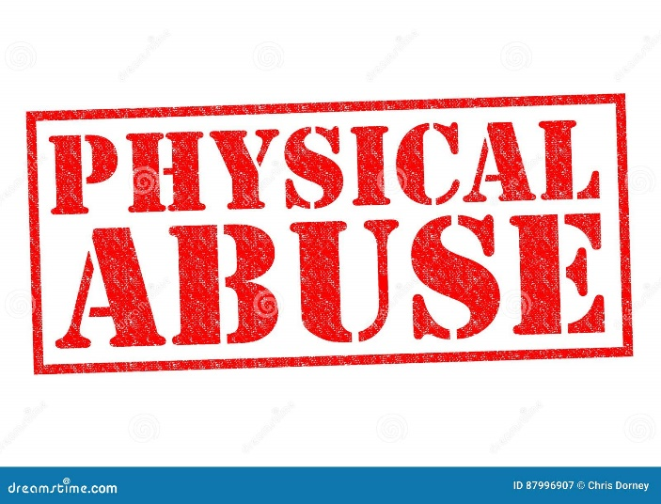

|  |  |
| --- | --- |
| **PHYSICAL ABUSE** | **SIGNS** |
| Hitting, slapping, pushing, kicking, hair pulling  Rough Handling  Scalding & Burning  Unlawful use of Restraint  Involuntary isolation or confinement  Misuse of medication  Forcible feeling or withholding food | Unexplained injuries  No explanation for inconsistent explanations  Physical marks – bruising, welts, burns, cuts  Frequent injuries  Unexplained falls  Subdued or changed behaviour  Failure to see medical treatment |

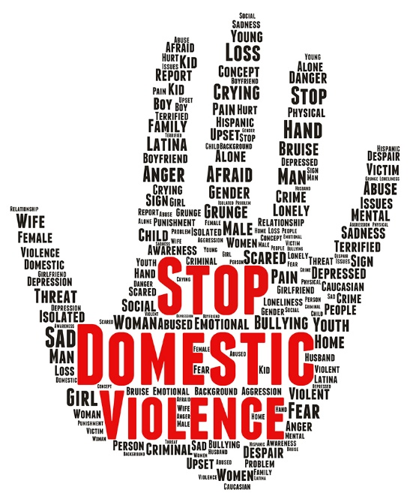

|  |  |
| --- | --- |
| DOMESTIC VIOLENCE/ABUSE | SIGNS |
| Psychological  Physical  Sexual  Financial  Emotional  Controlling Coercive | Low self esteem  Limited access to money  Isolation from friends/family  Physical signs – bruising, broken bones  Damage to home or property  Verbal abuse/humiliation in front of others |

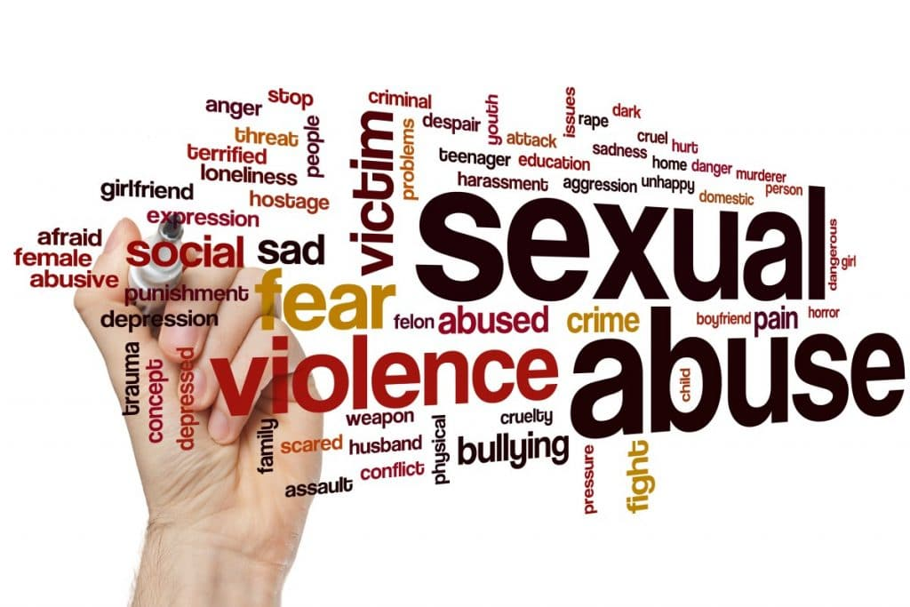

|  |  |
| --- | --- |
| SEXUAL ABUSE | SIGNS |
| Rape, attempt rape, sexual assault  Inappropriate touch  Non-consensual masturbation  Non-consensual penetration  Someone lacks the capacity to consent  Indecent exposure  Sexual Harassment/Photography | Bruising – thighs, buttocks, upper arms, neck  Torn, stained clothing  Unusual difficulty sitting/walking  Infections  Pregnancy – when unable to consent/under 16  Changes in sexual behaviour/attitude  Self-harming/Withdrawn |

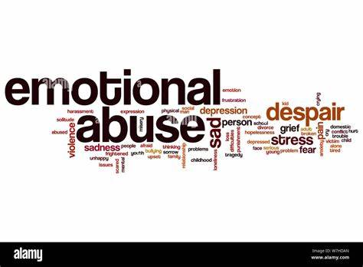

|  |  |
| --- | --- |
| EMOTIONAL & PSHYCOLOGICAL ABUSE | SIGNS |
| Enforced social isolation  Removing mobility/communication aids  Failure to respect privacy  Intimidation/coercion/harassment  Bullying/humiliation  Cyber bullying  Threats of harm/abandonment | Withdrawal or change in psychological state  Insomnia  Low self-esteem  Weight loss/gain  Uncooperative/aggressive behaviour  Signs of distress/tearfulness/anger  Silence in the presence of a particular person |

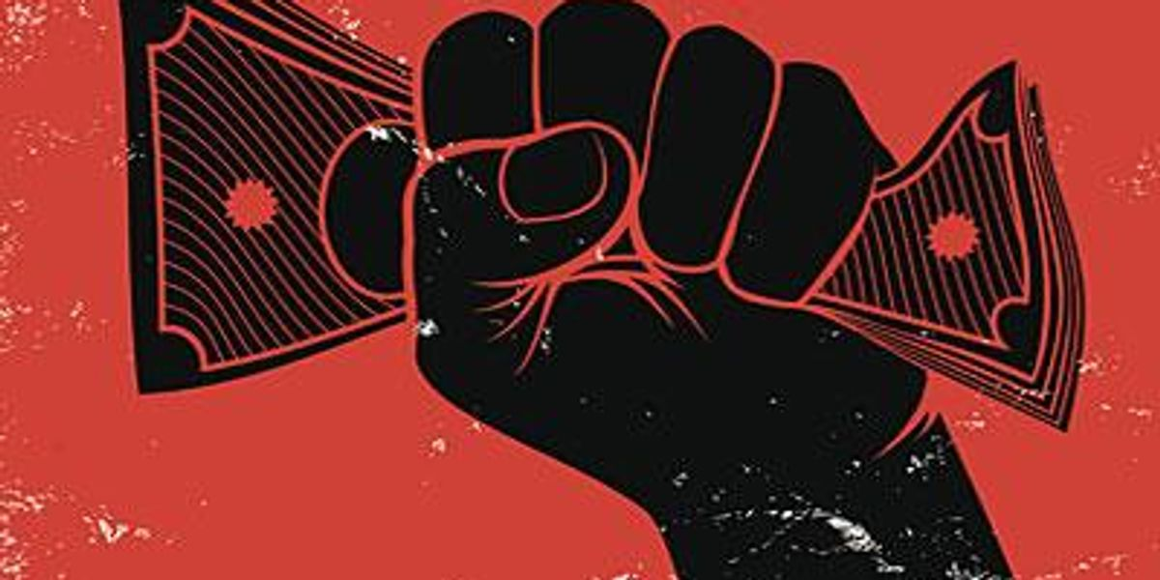

|  |  |
| --- | --- |
| **FINANCIAL / MATERIAL ABUSE** | **SIGNS** |
| Theft of money or possessions  Fraud / Scamming  Preventing access to money, benefits or assets  Misuse of personal allowance in a care home  False Representation  Exploitation of a person’s money/assets  Misuse of power of attorney | Missing personal possessions  Unexplained lack of money/financial hardship  Recent changes in deeds or title to property  Rent arrears/eviction notices  Disparity between living conditions and finance  Unnecessary property repairs  Being accompanied to make bank withdrawals |

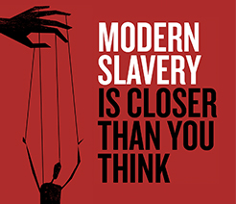

|  |  |
| --- | --- |
| **MODERN SLAVERY** | **SIGNS** |
| Human Trafficking  Forced Labour  Domestic Servitude  Sexual Exploitation  Debt Bondage | Malnourishment, unkempt or withdrawn  Isolation from community  Living in dirty overcrowded conditions  Lack of personal effects/ID documents  Fear of law enforcers |

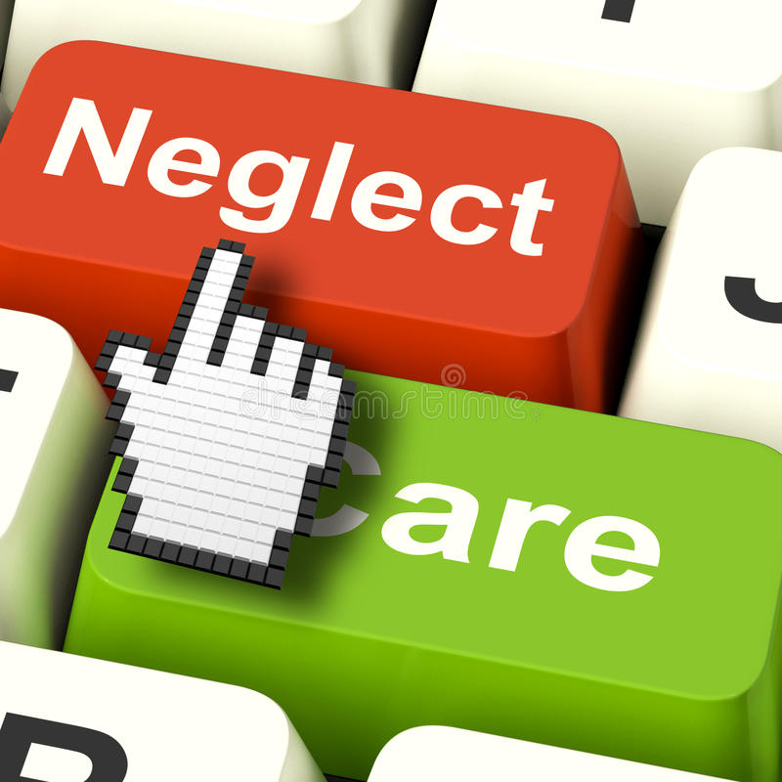

|  |  |
| --- | --- |
| **NEGLECT** | **SIGNS** |
| Restrict access to food/shelter/heating/clothing  Fail to provide personal/medical care  Refusal of access to visitors  Ignoring/isolating the person  Failure to ensure privacy/dignity  Disregarding cultural/religious/ethnic needs  Preventing person from making own decisions | Poor environment – dirty/messy  Poor physical condition/physical hygiene  Pressure sores/ulcers  Malnutrition  Untreated injuries/medical issues  Accumulation of untaken medicine  Inappropriate/inadequate clothing |

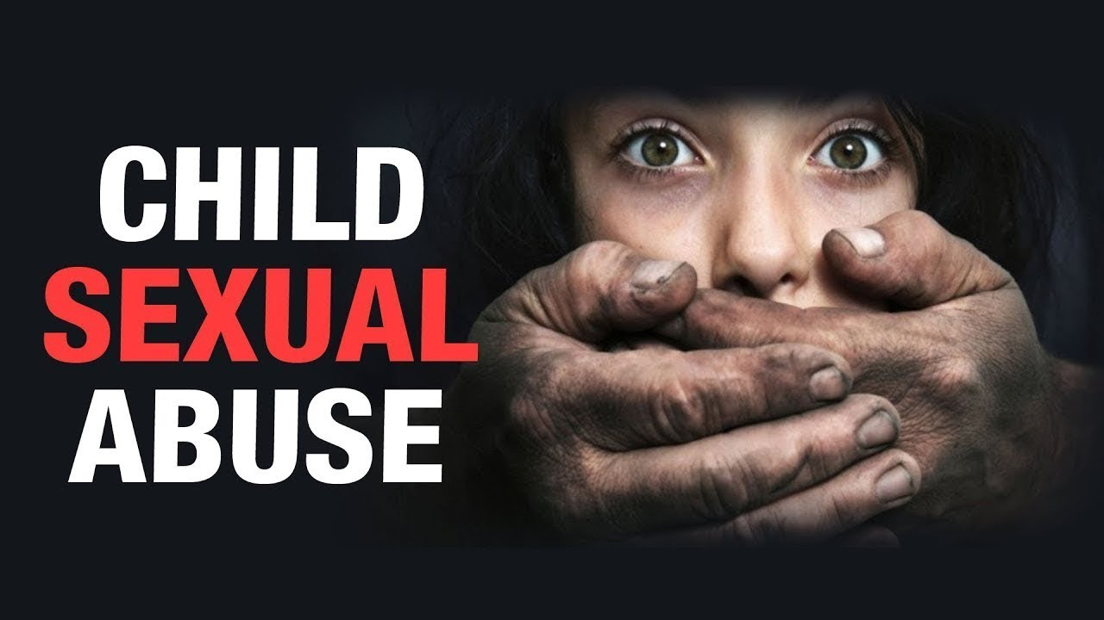

|  |  |
| --- | --- |
| **CHILD SEXUAL ABUSE -** CONTACT | **SIGNS** |
| Sexual Touching of a child’s body & kissing  Rape using a body part or object  Forcing a child to take part in sexual activity  Making a child undress or touch someone | Unexplained changes in behaviour/personality  Irritable/Aggressive  Anxious/Withdrawn  Self-harm  Running away  Being frightened of someone they know  Nightmares/Bed-wetting  Eating problems  Sexualised behaviour/language  Alcohol/Drug misuse  Suddenly wanting to miss school |
| NON CONTACT |
| Exposure/Flashing  Showing pornography  Exposing a child to sexual acts  Forced masturbation or sexual activity  Viewing, or distributing child abuse images  Sexually activity/conversations online |

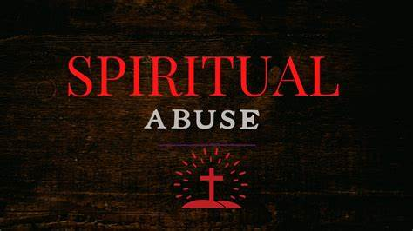

|  |  |
| --- | --- |
| **SPIRITUAL ABUSE (emotional/psychological)** | **SIGNS** |
| Ridiculing/insulting a person’s beliefs  Preventing someone from practising faith  Using faith to shame/manipulate/bully  Coerce/control through misuse of scripture  Misuse of divine position  Using spiritual threats  Fear of spiritual consequences | Isolation  Unhealthy boundaries  Invasion of privacy  Justification through scripture  Misuse of Authority  Supressing critical thinking  Pressure to give money |