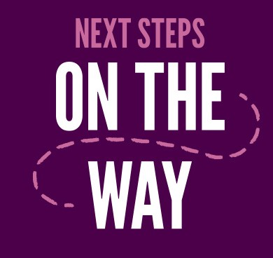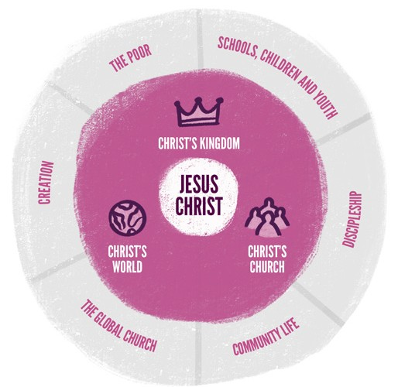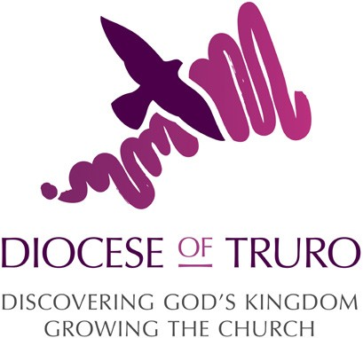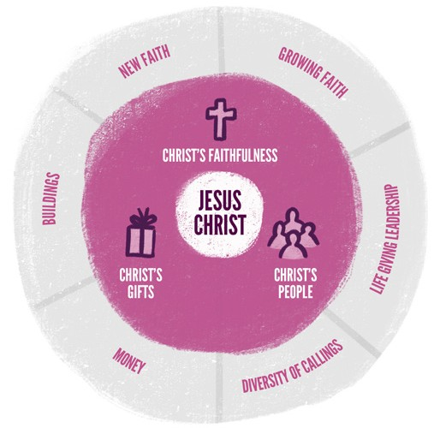
OUR PLAN

IF WE DO THIS ... | THEN WE WILL FEEL ... | AND WE WILL SEE ... | SO THAT ... | THE RESULT IS ...
 | - A sense of belonging.  - Safe and supported.  - A sense of purpose.  - A new awareness of Christ & God.  - Contributing to improving the world we live in. | - Improved support for the community.  - Improved links with schools, CYP & families.  - Improved discipleship.  - Improved links with churches worldwide.  - Improved climate & bio-diversity across the diocese. | - More children & young people worshipping Christ.  - All Churches engaged with social action projects.  - Net zero by 2030. | FRUITFUL  - Schools, children & youth.  - Discipleship.  - Community life.  - The Global Church.  - Creation.  - The poor.
 | - Able to explore faith in ways that speak to us.  - We know more about Christ, God & Faith.  - Feeling of wanting to share our resources; time, money, gifts.  - A link between the heritage of faith in Cornwall & part of shaping the future. | - Increased numbers of people coming to know Christ.  - Greater maturity amongst Christians.  - Improved leadership at all levels within the diocese.  - New models of ministry.  - Increase in finances. Improved use of church buildings.  - Theologically driven & ecclesiastical. | - New Christians.  - The right leadership in the right places.  - Sustainable finances to carry out God’s work.  - Mature Christians engaged with God’s word. | SUSTAINABLE  - Growing Faith.  - Life giving leadership.  - Diversity of callings.  - Money.  - Buildings.  - New faith.

