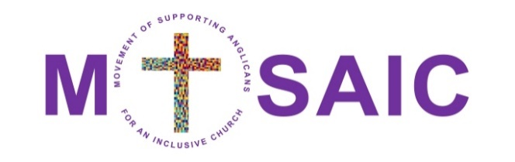
MOSAIC
Movement of Supporting Anglicans for an Inclusive Church

Welcoming - Enabling - Resourcing
The strength of the Anglican Church is found in its
breadth, comprehensiveness, and inclusion
(Chicago-Lambeth Quadrilateral 1888)
- MOSAIC is a grass root movement which campaigns for and models theological breadth, comprehensiveness, and inclusion.

- MOSAIC seeks a church where the God given potential of all is fully embraced and celebrated – calling for an end to all discrimination against people due to economic power, ethnicity, gender, gender identity, learning disability, physical disability, neurodiversity, mental health, or sexuality.

- It is the ambition of MOSAIC to have an active presence in every Diocese of the Church of England.

- MOSAIC is not a formal organisation or charity with a constitution or membership; it does not plan to have a bank account and generate income or expenditure of any significance, it does, however, have a national steering group, patrons and local convenors, working together for a truly inclusive church.

- Every Church of England Diocese is being encouraged to form its own local group Anne Brown and Andrew Yates have stepped forward to act as co convenors for the Cornwall group. They would really like to hear from anyone who wants to join the group or just find out more about what is involved

If you want to be part of this movement or to get more information please contact either
Andrew andrew.yates@truro.anglican.org or
Anne atlanticcoastcluster@btinternet.com

