From St Olaf’s, Poughill to Zambia, with Mission Direct
Alison and Mark Sinden
We first started visiting Zambia in August 2015 with a Christian charity called Mission Direct. Mission Direct sends volunteers on a two week ‘experience’ in various countries, assisting in a local community project ( building and decorating classrooms, refuges etc) and introducing volunteers to Christian partners on the ground. In Zambia, this means working alongside those in the large compounds or ghettos around Lusaka; areas of extreme poverty , enabling volunteers to have a more informed approach to the country in which they are working.
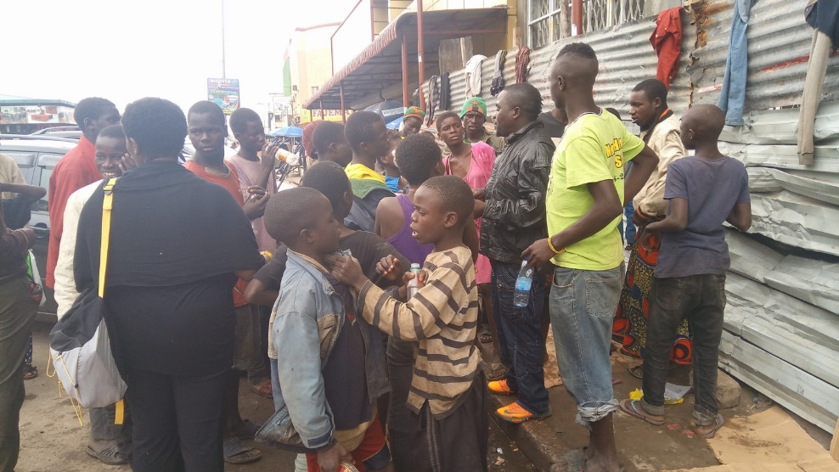
One of the local partners in Lusaka is the Footprints charity, which works with young people living on the streets. There are many hundreds of young people alone on the streets across Zambia, particularly in the larger towns like Lusaka and Livingstone. There are many reasons for this. The parents may have died of AIDS, a remarriage has forced unwanted children out of a family home, lack of available food has caused them to run away, and sometimes children have been dumped in the city to fend for themselves. These youngsters soon become addicted to a highly addictive drug called stika, which is a jet fuel derivative. This can be purchased very cheaply with money gained from begging or prostitution. These young people are often HIV positive and often die young from AIDS or other health problems.
We quickly realised that the only way to help prevent the spiral of a child being born on a compound descending into street life and a premature death, was to help educate them. The children in Zambia love going to school. If you meet a child growing up in the poverty of a slum compound, the chances are they won't go to school. Nor will their siblings. They know the only way out of their poverty trap is education. There are government schools but few of the compound children have an opportunity to go, so local volunteers set up Community Schools, of which the Crown of Life in Lusaka is one of the more successful. Lack of money is a huge factor in providing resources and paying teachers.
We have returned to Zambia regularly and established a sponsorship scheme in 2016 for some of the children attending Crown of Life School in Lusaka. The current school building was established in 2010 with funding from a UK church and Mission Direct volunteers helping with the build.
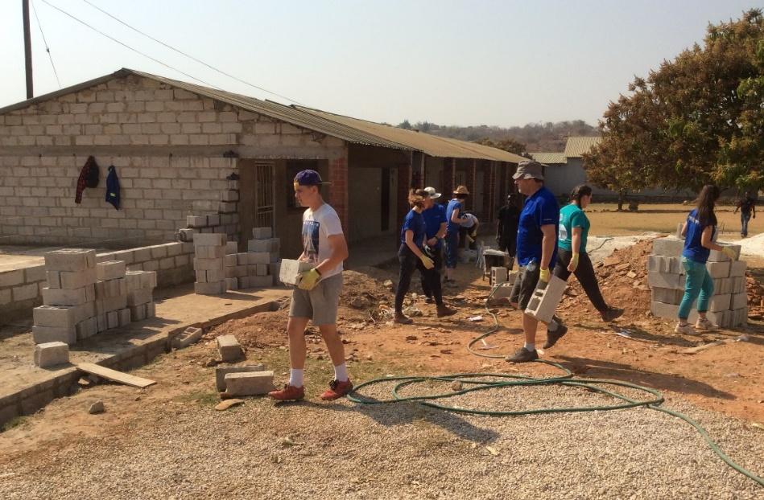
Since then, with the generosity of donations, the school continues to expand and develop. Classrooms are regularly added and now the school has over 500 pupils. The sponsorship programme allows the school fees to be paid and the child to receive a school uniform, shoes and a bag (very important in Zambia), the teachers receive a fair wage (thus attracting teachers of a higher calibre) and the school can continue to expand. Now there are classrooms to house children from reception to grade 12 (A level equivalent) and the school is now an exam centre. In 2019 the first grade 12 class graduated. A grade 12 qualification enables the child to gain a higher standard of employment or if funds permit, to move on to higher education.
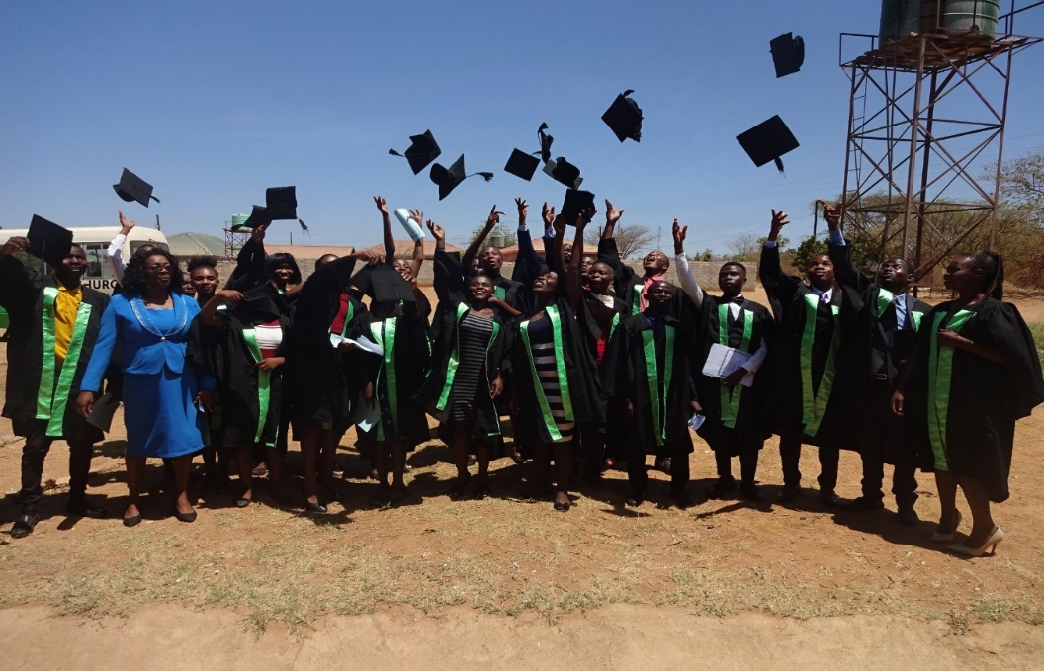
We now have 50 children sponsored through the scheme. Our church, St Olaf’s, in Poughill regularly supports Mission Direct Zambia and sponsors 2 of the children at the Crown of Life School. Many in church or other friends and acquaintances across the country, sponsor individual children or have given donations. The charity Mission Direct and the school are supported in prayer as are we, when we travel. We are thankful that in this small way, God has enabled lives of children and their families to be changed and the children can be given hope for a better future.

