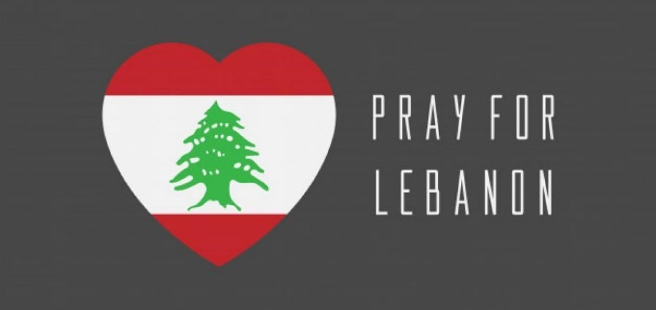
Lebanon Spring 2021 update
The Spring 2021 edition of the World Bank’s Lebanon Economic Monitor published at the beginning of June ranks the ongoing financial and economic crisis in Lebanon as now among the worst 3 globally since 1850, the others were all linked to the impact of armed conflict. But Lebanon has now had a year and a half of compound challenges in peace time, resulting in a 40% reduction in per capita GDP and a 90% reduction in the value of the Lebanon Lira, which the World Bank had previously christened a ‘Deliberate Depression’ because the Lebanese authorities have refused to take any effective action in the face of colossal challenges, which includes the failure of parliament to agree a new coalition government after the last one fell many months ago. This failure is said to be due not to a lack of knowledge or quality advice but a lack of consensus over effective policy initiatives, but conversely due to a policy consensus in defence of a bankrupt economic system, which has benefitted an elite few for so long.
The World Bank fears that the freezing of the bank accounts of private individuals and small businesses, together with a sharp deterioration in basic public services for which an increasing proportion of the population have no alternative private sector access, (electricity, water, sanitation, education and health services) and the fact that 50% of the population is now living below the bread line, is likely to drive increasing social unrest, possibly spilling over into violence. At the end of June, about 100 men stormed the Beirut head office of a major bank, trying to access closed accounts and injuring three employees. Staff felt coerced into transferring funds into accounts in Turkey. In the same period, there were attempted break-ins at branches of the Lebanese Central Bank in Tripoli and Sidon.
On top of everything else disastrous medicine shortages are now predicted says a Lebanese business association as imports ‘have almost completely ground to a halt’ During the month of June, due to a lack of foreign currency to pay the overseas suppliers.
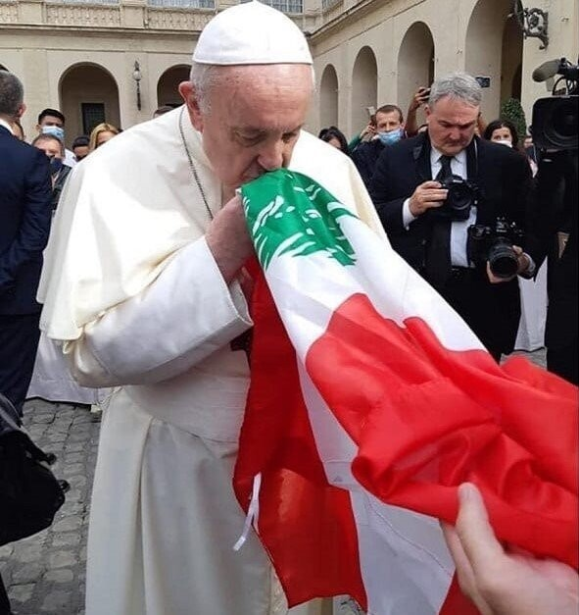
At the beginning of July, Pope Francis convened a meeting of the heads of Lebanese churches at the Vatican and held a special day of prayer for Lebanon under the title ‘God is a project of peace. Together for Lebanon.’ ‘Let us seek the inspiration of the Holy Spirit for all spiritual and secular officials to work together with honesty and faith to save their country from its depression.’ As well as the political and economic crisis, the leaders shared their fears for the future of Christianity in Lebanon – since August 2020, some 380,000 Lebanese Christians have applied for emigration to EU or North American states. They reaffirmed the urgent need to form a new government to overcome the institutional paralysis. In response, the Pope called on people to ‘sink our roots into the dream of peace’ as it is from their roots that flowers bloom. He went on to refer to the woman from the region of Tyre and Sidon (now the southern part of Lebanon) who insistently begged Jesus in her suffering ‘Lord, help me!’. Today her plea has become that of an entire people he said.
All the churches are working flat out to minister the needs of those unable to afford food and suffering health and other crises. But the challenge is great when half the population just does not have the means to buy basics. The pastor of a hub church in Beirut which has a substantial well established network of social and health care for its surrounding community and is feeding many in need has been preaching for the last three weeks on being salt and light, saying that the harder the situation gets in the world the greater the opportunity for the church to fulfil its mission to be salt and light.

