St Kea Link with Compassion in Kenya
A few years ago the PCC at Kea church decided to increase their giving to others for mission (broadly defined as including both evangelism and works of mercy), whether locally, nationally or internationally, to 10% of all our income. The increase to this level was made in steps over several years but has now been reached. However, disbursement of the funds allocated for mission lagged behind, leaving us with a substantial underspend. Whilst reviewing giving to our existing mission partners we agreed to adopt a new partner, Compassion UK, which provides holistic church-based support in a number of developing countries.
Whilst Compassion’s tag line is “Releasing Children from Poverty in Jesus’ name”, in practice it is not just children who benefit, rather whole families and indeed communities can benefit from the support given. We discussed with a member of Compassion’s staff based here in Cornwall the use of our accumulated underspend to fund a specific “intervention” project but, due to Covid, virtually no capital-type projects were being undertaken, so we agreed to fund for a year a “Child Survival Unit” based at St Paul’s Anglican cathedral in a poor area of Embu, Kenya. The project, one of a number based at the cathedral through Compassion, funds ante and post natal care for fifteen mothers and their babies through the first year of life, including medical help, advice with feeding etc., as well as assistance to the mothers (and fathers if they are willing) with basic skills and help towards income generation. At the age of one year the babies can transition into a sponsorship program which will facilitate their ongoing development physically, mentally, spiritually. The local circumstances have been described to us as follows:
“A large number of the sponsored children live in the slum areas surrounding our church. We are surrounded by four slums . For this reason, our children face quite a number of challenges some of which include lack of proper medical care thus high rate of mortality, lack of quality educational facilities, unemployment of their parents because of their low levels of education, high level of drugs and substance abuse, lack of good and safe shelter, family instability and breakages, moral decay, juvenile delinquency, child neglect, HIV/AIDS to mention but a few. As we carry out our duties, these are some of the needs we try to address. We seek your support in prayers as we pray for enough grace and success of this project.”
In an ideal world, and as part of our Missions policy, we would be looking to establish longer term links with the host church in Kenya in order to develop a relationship in which both churches could benefit from each other through prayer, material support and mutual encouragement, as well as possible mutual visits. Whilst we can give financially, we think that Western Christians have much to learn from the faith of those who are less materially wealthy, but who may, as a result of being less distracted by possessions, enjoy spiritual riches and simplicity of relationship with God that would inspire us, as well as a sense of community in church life that would challenge our individualism. However in the light of Covid and its associated travel restrictions there are currently limits on how we can develop this relationship. Moreover, at this stage we have made no ongoing commitment beyond this year of lump-sum funding (our missions budget is not large enough to fund this project on an ongoing basis but we will be exploring whether, with other local churches, we might maintain funding for longer). So in these unusual circumstances we wait to see how the relationship will develop.
Nevertheless, we have already written to the church in Embu introducing ourselves and mentioning a number of areas where we would appreciate their support in prayer. In response, and almost by return, we had a lovely letter back describing the ministry of the cathedral and their various projects with Compassion, which include working towards building a new centre to house the projects, as well as a number of areas where they would like our prayer support. We have made the members of Kea aware of these and will be communicating further in due course.
St Kea Missions Working Group
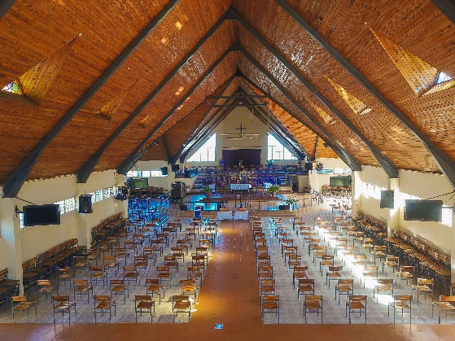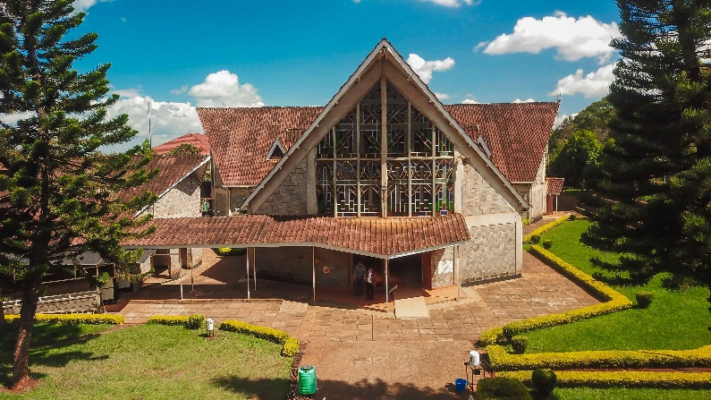
St. Paul’s Cathedral, Embu
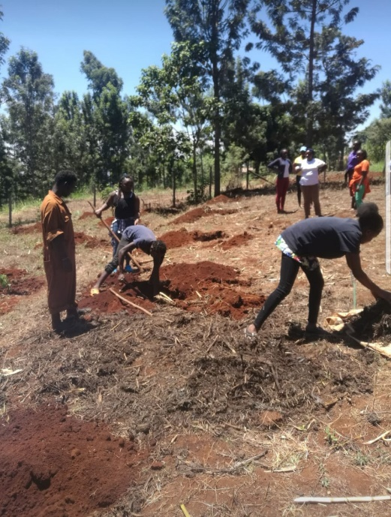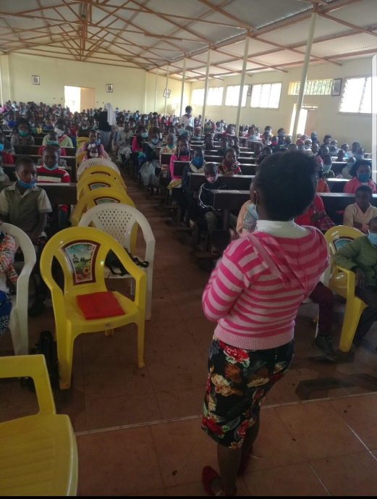
Work on the plot for the new centre An instruction session

