Ikona Hillside, Uganda and Sir Robert Gefferys Primary School
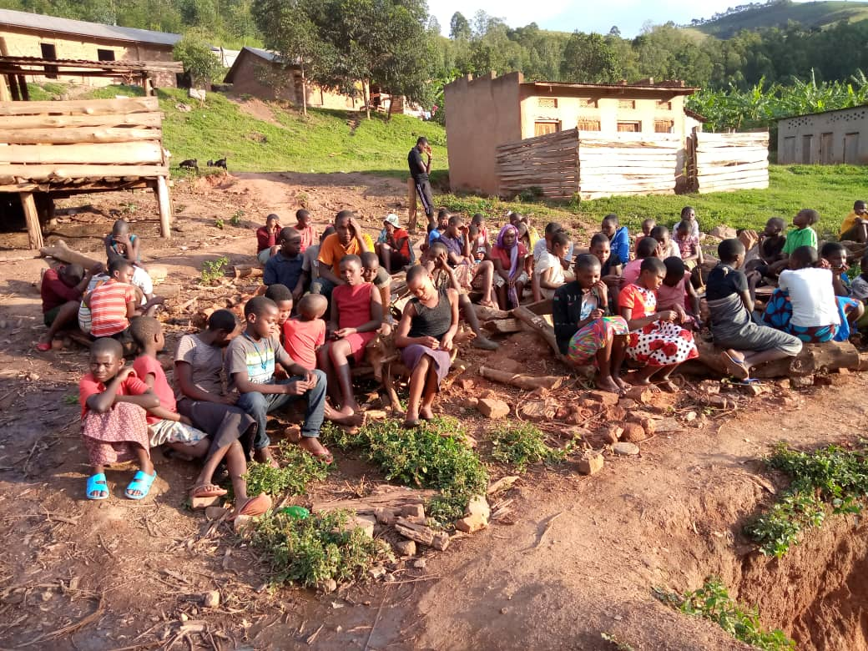
Over the last decade Ikona Hillside and Sir Robert Geffery’s Primary School have been a strong partnership. There is regular communication between the staff and the children, there has also been a variety of collaborative projects between the two schools. Teachers from Sir Robert Geffery's were due to visit Hillside in April 2020 but due to travel restrictions that has been put on hold. However, that has not stopped the two schools working together. Over the last 12 months the children in upper Key Stage 2 have been sending written letters (there have been delays in correspondence due to the post offices in rural Uganda being closed off). Yet, when the responses arrived from the children of Hillside there was great appreciation from the students. It enabled the children to learn more about life in rural Uganda. It highlighted the fact that all communities have found the last 12 months tough. It has also made children understand that there are many similarities between them such as; hobbies, friendships, love of animals - to name a few. These letters and correspondence have engaged and often been thought-provoking to all children involved.

On top of this we have a continuing collective project that follows the Sustainable Development Goals (SDG). In this project we are aiming to reduce the amount of waste we produce. If there is waste produced we are trying to create a project around it. At Sir Robert Geffery's we have been using wasted food packaging to produce our own style of recycled art. We are using the work of Michelle Stitzlein as a source of inspiration.

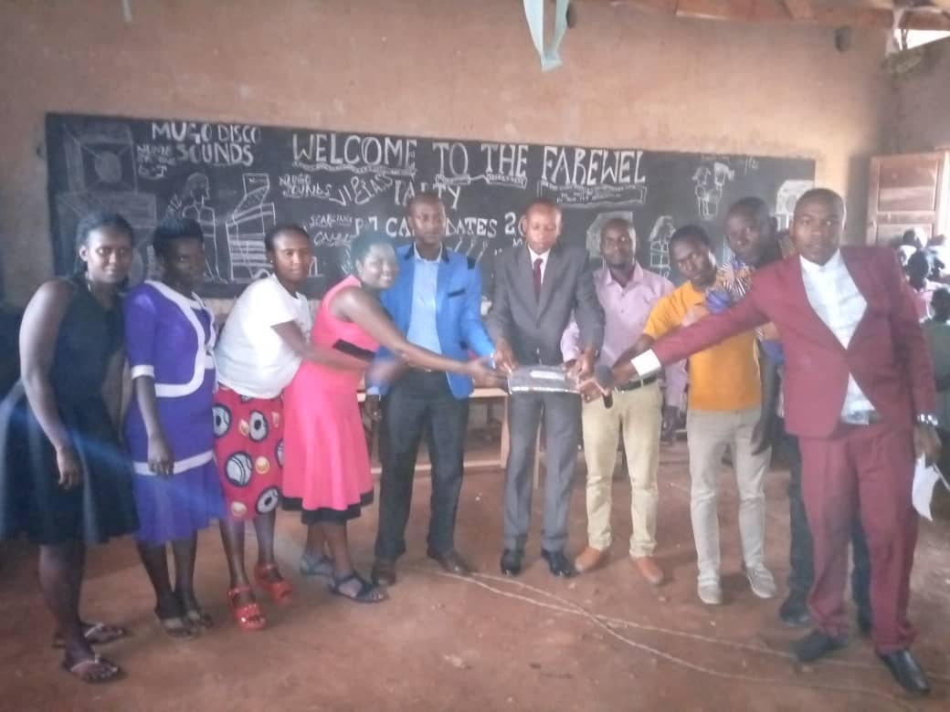
As a school we also include the wider community. There are regular updates as to what is happening at Ikona Hillside. These updates are shown on the school newsletter. Furthermore, there is a community project entitled ‘Suitcase of Culture’. A suitcase has been placed at the entrance of the school. People from the school community are able to put in resources that they feel will support the children of Ikona Hillside e.g. stationary. But it also offers the chance for people to include small items that inform the children and adults of Ikona Hillside about Cornwall. Currently, there are small jigsaws of Cornish landscapes and other items.

There is optimism that a couple of members of Sir Robert Geffery's will be able to visit Ikona Hillside in the not too distant future. However, until that happens the school staff, pupils and local community will continue to show support through love and prayer.

