Reflection from Revd Canon Perran Gaye, Chaplain to the Isles of Scilly
Each of us will have a different experience of lockdown, but perhaps two aspects may be true for all of us.
- We may well feel the sense that everything is in a state of uncertainty and flux, as we wait for the full effects of the ‘second wave’ and we begin to imagine what the ‘new normal’ might be like, and how our lives and world may be changed again with the promise of a vaccine. How long, O Lord, how long?
- We may also feel a sense of being confined to one place, or of being restricted to a narrower diet of duties and delights than in normal times, as the compass of our world shrinks during the lockdown.
Monastic communities, together with the millions of lay and ordained Christians who follow the Rule of St. Benedict, have a precious insight to share with us during this time of the pandemic. One of the three vows they take is the vow of stabilitas. The word means more than simply stability: it is about commitment to the here and now, for that is where we will find God. The Benedictine monk or nun promises to remain in one community for life. They are not allowed to run away to find God somewhere else, for God is not elsewhere. By practising a disciplined life of prayer and work and study, they become rooted in God’s love where they are, so that the challenges and joys of ordinary life become bearers of God’s presence.
In our present global crisis, God has given us a promise to be there for us as a fixed point of repose and stability in a time of flux, and to share something of the richness of his love for us within the narrowness of our confinement.
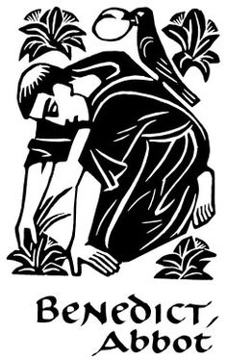
Happy are those
whose delight is in the law of the Lord,
who on his law they meditate day and night.
They are like trees
planted by streams of water,
which yield their fruit in its season,
and their leaves do not wither.
In all that they do, they prosper.
Psalm 1.1a, 2-3

