We are praying for you as you pray for us to love our city and country courageously.
Through your partnership, many are hearing and experiencing the love of Jesus.
Read below the stories and highlights from this month. Thank you for praying for these
ministries and the people they impact.
Restoring and renovating homes and buildings that were impacted by the August 4th explosion has continued.
Today we have been able to help a total of 175 homes and buildings so far. This
includes:
- 145 houses/apartments (out of which 35 are RCB congregants)
- 2 schools
- 2 church buildings
- 1 dispensary
Please continue to pray as the relief team and the pastoral team, hand in hand, are
working to help the families affected in a holistic way.

An increased number of vulnerable families received food and hygiene parcels due to increased giving we received this month.
As a response to the additional needs caused by the economic collapse in Lebanon during 2020, our relief team has supported a greater number of families on a monthly basis. This has been a great way to connect with people, share the gospel, and support those most in need within the church and wider community.
Also, from January through September 2020, we were helping 900 families every other month (450 families / month). In September and October 2020, we have been able to help families on our lists every month.
- 1,120 families received monthly food parcels
- 1,120 families received women’s hygiene products
- 250 children received diapers

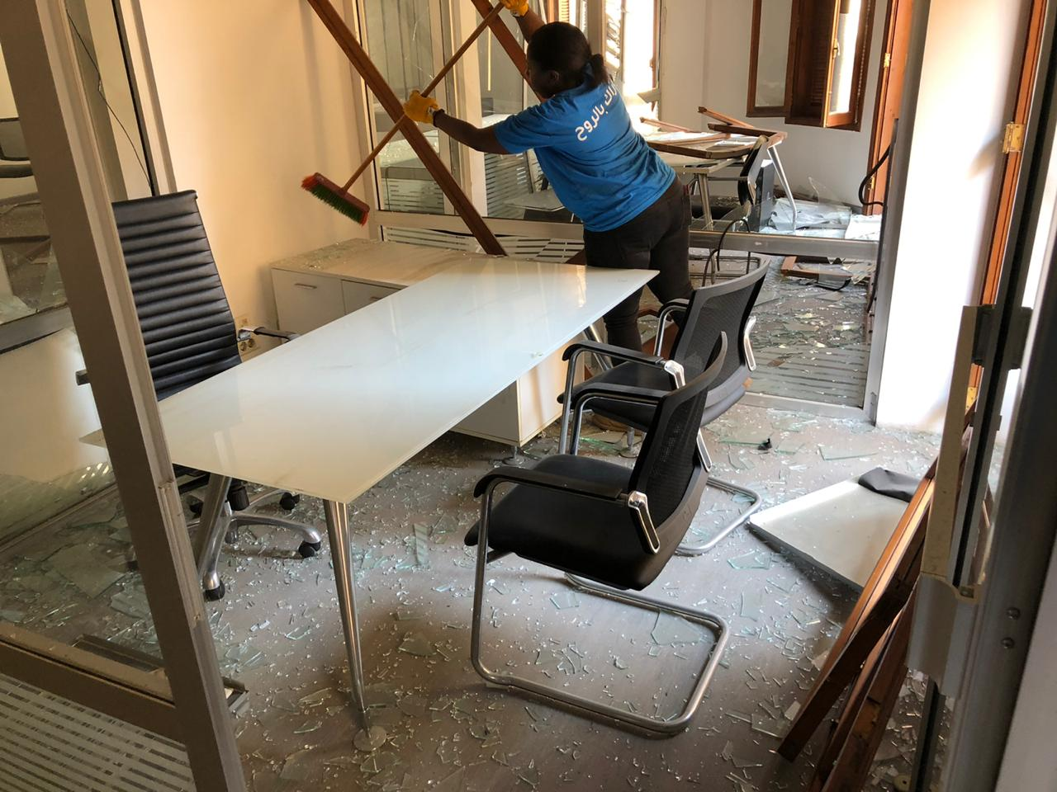
Teams from RCB were sent out to clean multiple floors in an office building that was damaged from the explosion. The owner of this building has been touched by these teams and there have been many opportunities to share Christ with him and his family.

