Bishop Philip’s appeal for the suffering following the explosion in Beirut channelled support to Resurrection Church in the port area of the city. One month on from the explosion we received this news from them.
----------------------------------------------------------------------------------------------------------------------------------
We are praying for you as you pray for us!
It has been more than one month since there was a large explosion that shook the city of Beirut. In this month, our church family has been wrestling through what it looks like to be the Church in our afflicted city. In Christ, we can live with courage through these times. We know that God has not forgotten us nor abandoned his people. He is doing a work in this city that is glorious and it is our honour to partner in that work with Him.
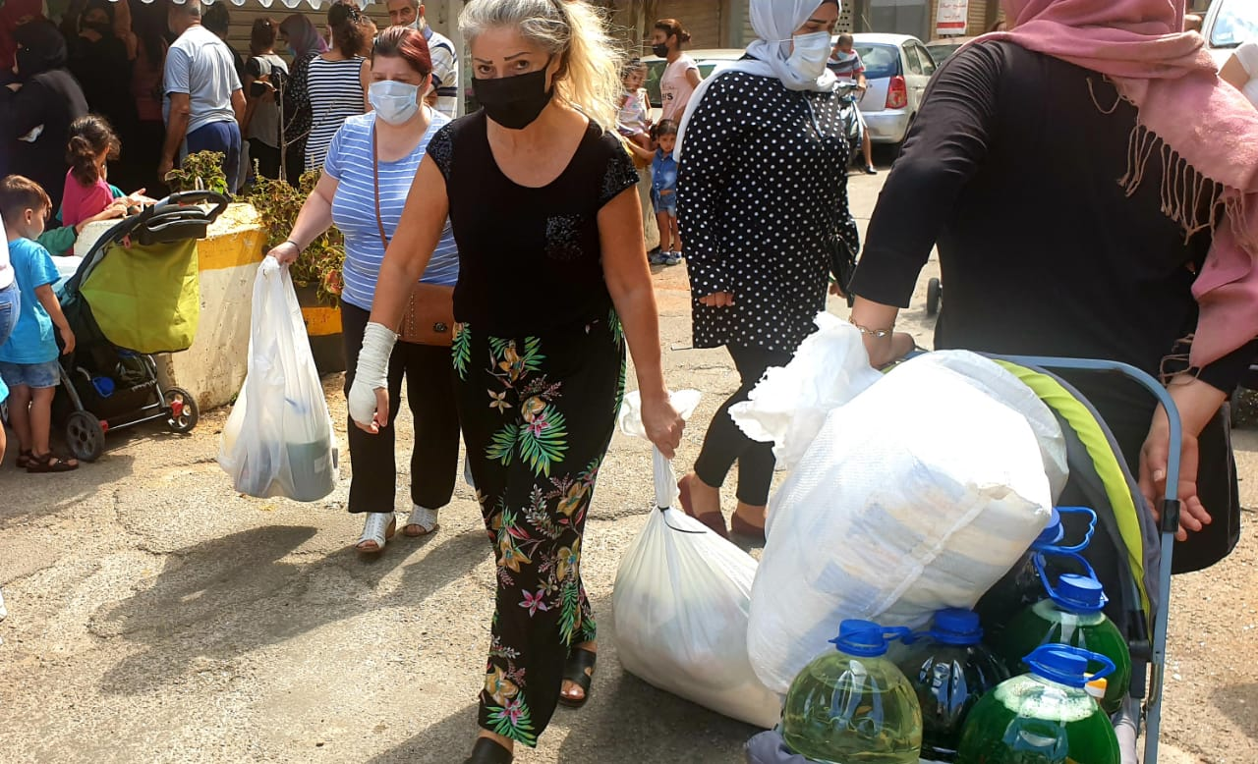
Due to your generous support, we were able to help many who were affected by the explosion. Here is a brief report of what has been done so far. The work done so far:
https://www.youtube.com/watch?v=P_qtG6oELFs&t=4s
- 42 houses cleaned, removal of hazards, & basic renovations done,
- 54 homes visited. Teams have prayed over the area affected by the blast as well as prayed for and provided food for families in the area.
- 35 caregivers trained on PTSD & trauma counselling 1,850 food portions distributed to families.
- Free doctor’s consultation, treatments, and medication for those injured in the blast and others at our ‘Al Shafy Clinic’ (the Healer).
- 70 houses renovated
- 28 financial gifts given
- 5 partners helped with renovation
- Repaired the damage at our campuses in Sabtieh and Nabaa
We are so thankful for your generosity! Our emergency budget for those directly affected by the explosion has been fully met! Our priority is to handle this budget faithfully and effectively, within the capacity of our team.
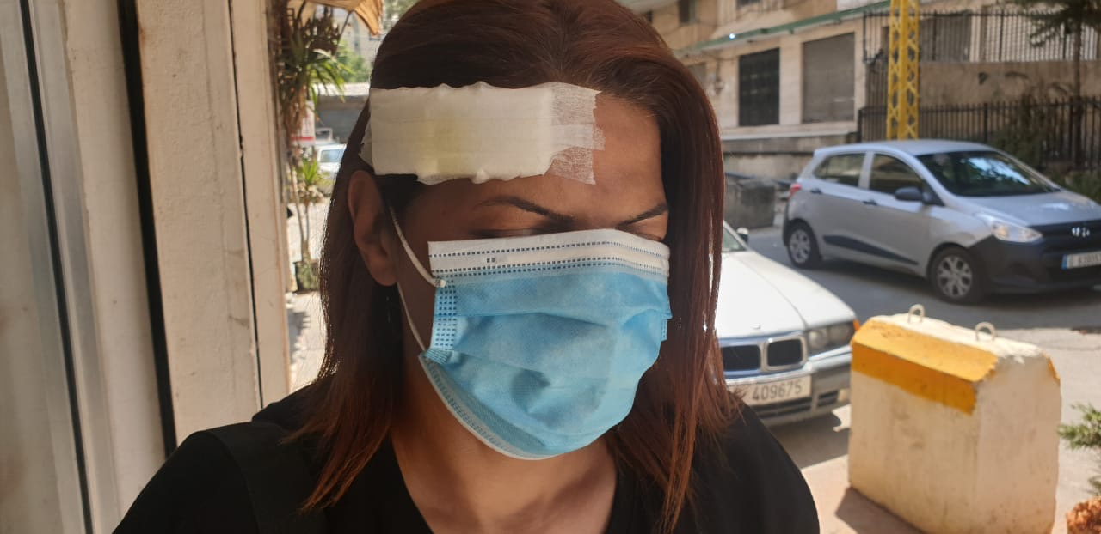

Hannah lives in a one room apartment in Nabaa with her young son. When the blast happened, her glass window exploded and she suffered an injury to her head. Her son, who was with her, was spared. As a church, we were able to stand with her during this hard time and help her in different ways. Pray for this relationship among many relationships built during this time.
TESTIMONIES
I went to a pharmacy recently, and people were there sharing stories of hurt and how they are desperately in need for help. It was an opportunity for me to share about Jesus and about how the church is serving and standing by those affected by the blast. I had visited this pharmacy many times, but today was the first time I got to witness about Jesus and His church through this small encounter. God is opening countless doors to us every day. It was a reminder of the call to go through daily life with intentionality to share Jesus. -RCB member.
I am not the type of person who is able to ask for help. I am too shy. Even when I need it. And you (the Church) have come and served my needs without even having to ask. I am so grateful. -Man injured by the blast.
"Thank you so much for all the practical help that you have offered. Thanks for repairing the windows and doors at our house. I am really blessed by knowing you." Through this relationship, this woman connected with our church leaders more and is now attending the parenting sermons each week.

