Bishop Philip’s appeal for the suffering following the explosion in Beirut channelled support through CMS (Church Mission Society) to Resurrection Church in the port area of the city. Two weeks on from the explosion we received this news from CMS.
----------------------------------------------------------------------------------------------------------------------------------

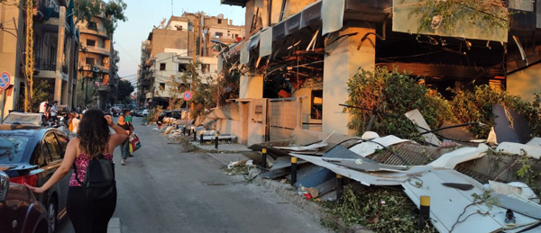
“As the dust begins to settle in Beirut, a fortnight after the devastating explosion, the hearts of Lebanese people are far from settled. So many are only just now coming to terms with enormity of the event. People’s moods are heavy. Many struggle to sleep. Mourning continues for lost loved ones and also for the loss of familiar places: shops, businesses, cafes, restaurants. For many, what was once the heartbeat of the city is gone.

“As a result, we hear many stories of people wishing to leave Lebanon – a surprising number have foreign passports or nationality. Last week, my Uber driver, who has a wife and two young children, was very determined to join his cousin in Canada as soon as he can. He was driving at the time of the blast and both the front and back windows of his car were blown out. Luckily, he was unscathed. ‘As I got out of my car it was like the scenes from the civil war,’ he said.

“Meanwhile the clean-up continues... Various volunteer groups have become remarkably organised on their own initiative, with coordinating committees, databases of needs and available resources. A sign of just how resourceful Lebanese people are.

“Sadly, the focus on the explosion has inevitably meant measures to contain Covid-19 have become hard to implement. Reported Covid-19 cases have multiplied significantly. We have just learned that from this Friday the country will go into a two-week lockdown with a night time curfew to try to curb the spike in cases. The area around the port is exempt so the urgent reconstruction work can continue.”
Lebanon: An eye-witness account:-
https://churchmissionsociety.org/our-stories/lebanon-one-week-on/?utm_source=Church%20Mission%20Society&utm_medium=email&utm_campaign=11762789_Call%20in%20Action%2019%20August%202020&dm_i=1MYY,70485,FTMVO2,S7YGS,1

If you’d like to join our people in mission in praying for peace and justice in Beirut,

https://churchmissionsociety.org/resources/peace-without-justice-is-no-peace-at-all-a-reflection-from-beirut/?utm_source=Church%20Mission%20Society&utm_medium=email&utm_campaign=11762789_Call%20in%20Action%2019%20August%202020&dm_i=1MYY,70485,FTMVO2,S7YGS,1

In Christ,

Naomi Steinberg
Head of Communications

