Introduction

If the absence of bread flour and yeast on our shop shelves during lockdown is anything to go by we have become a nation of bread makers once more. Perhaps for some there is more time available and the making of a household staple has been a return to a wholesome, slow and home based act of provision and nurture for ourselves and our families. For many mothers though this image of reflective baking and the smell of homemade bread filling our homes mocks the ‘domestic goddess’ we may aspire (and fail!) to be and is a far cry from the muddle of juggling work, child care, home schooling and the lack of physical and emotional space we have for self care and time with God.

The following reflections are offered as a way to meet God in the mess and muddle and to perhaps deepen our awareness that God comes to us offering just the ‘bread’ that we need for the day. Manna - like this ‘bread’ is just for the moment we find ourselves in, not for accumulation but just today’s mouthful in recognition that tomorrow we will return hungry again and ask once more for what we need to get through these strange, dismantling and formative days.

This month of reflections takes the practice of making bread and uses it to explore how this process may find its echo in our life with God and our life-living with our families. It does not require any bread making (unless you want to!) but just the willingness to be present to the daily act of making food for ourselves and our families. This may be slicing bread or toasting it or making a sandwich or cutting and cooking vegetables for an evening meal. The specific activity itself is less important than the ‘attaching’ of these daily reflections to that repeated daily action of preparing, making and baking meals to share with those we spend our days with.

God chooses to come to where we are and meet us in the mundane, repeated habits of our human lives. Time to be quiet and to ‘retreat’ may be in very short supply and so these reflections are designed to simply break into our consciousness and remind us that God is with us as we go about our daily round. Just perhaps a question to chew on as we go about our work.
You might like to print off the reflections and cut them up and then blue-tack a new reflection above the toaster or bread bin either last thing at night or as you prepare breakfast each day.

Give us this day our daily bread :

a month of bite-size reflections for busy mothers

Week 1: weighing and mixing the ingredients of our lives

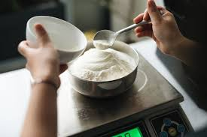

‘Our firm decision is to work from this focused centre: One man died for everyone. That puts everyone in the same boat. He included everyone in his death so that everyone could also be included in his life, a resurrection life, a far better life than people ever lived on their own.
Because of this decision we don’t evaluate people by what they have or how they look. We looked at the Messiah that way once and got it all wrong, as you know. We certainly don’t look at him that way anymore. Now we look inside, and what we see is that anyone united with the Messiah gets a fresh start, is created new. The old life is gone; a new life burgeons! Look at it! All this comes from the God who settled the relationship between us and him, and then called us to settle our relationships with each other’
2 Corinthians 5 (TheMessage)

.

Monday
Weighing : before ingredients are mixed they must be weighed.
What carries weight in your life just now?
What measure do you use to weigh or evaluate your own success, or effectiveness, or worth?
As mothers there is huge potential for maternal guilt, weighing ourselves against external standards and finding ourselves wanting! Might we start this month by receiving the hand of friendship God offers us? Here in the grace of God we stand, there is no condemnation.

Tuesday
Mixing ingredients: A particular mix of ingredients is needed to make bread. In a similar way our own lives are made up of a number of parts or components that may change over time. These different ingredients perform a variety of functions in our life and faith and are blended together and react with each other in a way that makes up the ‘bread’ of our daily living.
What are the different ‘ingredients’ of your life at this time?
How well do the different parts and roles of your life mix together?

Wednesday
FLOUR: flour forms the plain filling ingredient of bread. It makes up the basic substance and provides the background that the rest of the ingredients are mixed into. What are the basic routines of your life just now- the non-negotiable responsibilities, the fixed points, the main substance of your daily routines and rhythms?
It may be helpful to write them into the ‘flour’ section of the image overleaf

Thursday
YEAST: yeast is the ‘live’ ingredient that swells the bread and enables it to grow and expand. If this ‘live’ ingredient is too powerful it can swell the bread to unmanageable proportions! But equally if the yeast doesn’t provide enough ‘life’ the bread is flat and heavy. What are the ‘live’ aspects in your life at this time both for you as an individual and as a family member? What are the issues, questions, challenges and areas of development you and your children are experiencing at this time? Is there too much activity or not enough life and growth? Where and how are you enabled to grow? Make a note of these on the diagram overleaf.

Friday
SUGAR: sugar brings a sweetness and an activation of the ingredients that enable us to grow. Along with salt it also provides flavour. Is there anything in your life just now that tastes good and sweet? What are the components of your present circumstances that you enjoy and are life-giving for you and your family?

Weekend
WATER: water acts like glue, holding the bread ingredients together in a coherent whole. Without the water that holds and binds us we remain inert and unconnected and our potential is unrealised. Do you have a sense of the beliefs and values that hold your life together, that turn you from a set of components into a whole person? Perhaps also the ‘water’ that binds you together in family life? You may like to jot these down too on the image below.

Spend some time looking at the four ‘ingredients’. How much do you have of each ingredient? Is there too much or too little of one? Might there be a shift in balance as you move into the different stages of your faith journey and family life?

Ask the Holy Spirit for insight and wisdom to see how you might make a good mixture of the different areas of your life in this particular moment of your walk with God. You may wish to make a simple intention or commitment to shift the balance of ingredients.

Offer each ‘ingredient’ of your life in turn as you have measured and mixed them as an act of prayer and commitment to God.

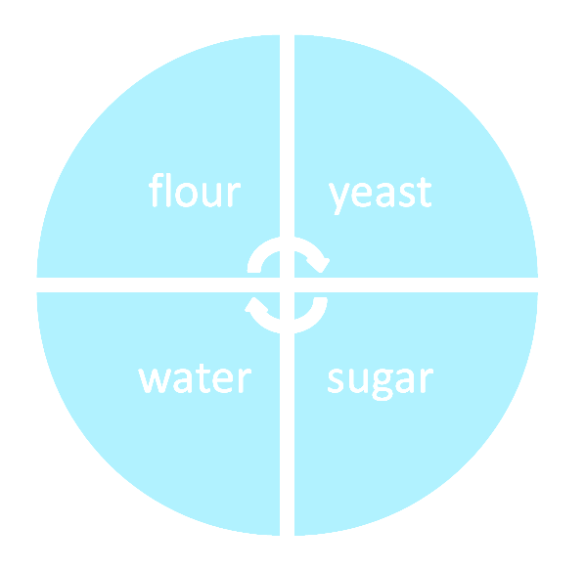

Week 2 : Resting and Rising

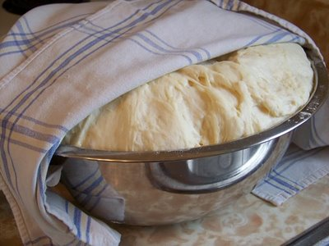

For the ‘live’ ingredient to do its work it needs an activator. In bread making the yeast is often activated by the sugar. Once these components are brought together they then need space and time to rest and rise. We cover resting bread to protect it and it is often put in a dark place and left alone until the raising work is achieved.

In the life of Christ we see this rhythm of resting and rising. Jesus took himself off to quiet places to reconnect with the Father, the source and power of his earthly life and ministry. He observed (as well as challenged and reinterpreted) the rhythm of keeping the Sabbath. We see this pattern of resting and rising ultimately in his resting hidden in the tomb after his death and the rising to new life that we celebrate at Easter and on every ‘first day of the week’. In his rising we see in powerful form the activating work of the God as he brings resurrection and new life.

Whoever dwells in the shelter of the Most High will rest in the shadow of the Almighty.He will cover you with his feathers, and under his wings you will find refuge Psalm 91

Monday

How might God be active in your life and circumstances, personally, within your family life and in the wider world? Do you keep any kind of ‘sabbath’ in your family life?

Tuesday

Think about your own daily and weekly routines. Are there any ‘resting’ places? Do you have a quiet hidden time of day or a place that you associate with rest and regeneration and prayerfulness?

Wednesday
Can you think of one simple action or intention you might make to preserve this empty space where apparently nothing useful happens and yet growth and rising is activated from within? Perhaps to stand still while the kettle boils and let the steam rising be a symbol of the prayers and desires of your heart being lifted to God.

Thursday

What area of your life needs growth, regeneration and resurrection at this time?

Friday

Spend some time just resting in God’s presence. Perhaps last thing at night as you settle under the covers to sleep. Allow yourself to be hidden away covered in his deep knowledge and love of you. Try to rest without words and to be still in your mind and body. Let this be an act of trust that as you rest God’s rising work will be done.

Weekend

Look back over this week. Have there been any times of resting? What made it possible to have that time and space to be ‘covered’? Are there ways you might ask for the help of your partner or friends or family to enable you to get regular time to rest?
Listen to the following song (Holy Overshadowing by Graham Kendrick) as you ask God both to give you rest and to lift your head to all He is doing in your life and in his world.

https://uk.video.search.yahoo.com/yhs/search?fr=yhs-itm-001&hsimp=yhs-001&hspart=itm&p=holy+over+shadowing+graham+kendrick#id=1&vid=73023b5bb769ef39eb865a4ff463873d&action=view

Whoever dwells in the shelter of the Most High will rest in the shadow of the Almighty.
He will cover you with his feathers, and under his wings you will find refuge Psalm 91

Week 3: Kneading and baking

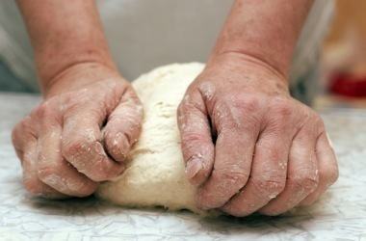

The term used for kneading dough after it has rested and risen is ‘knocking back’. Here the bread is handled firmly to remove the air that has puffed it up. The bread is reworked to get the most out of the yeast or raising agent and to give the bread form, substance and elasticity. It is then reshaped in order that it can be rested once more in preparation for baking. Once all the work has been done we trust that the oven will do its work and transform our ingredients into good bread that will nourish and sustain us, and which can be offered to others.

‘…work out your own salvation with fear and trembling; for it is God who is at work in you, enabling you both to will and to work for his good pleasur’e. Philippians 2:12.13

Monday

When you think about your own life with God and the life of your children and wider family are you aware of ways in which you are being re-worked, ‘knocked back’ even?

Tuesday

Is there any sense that God is at work in this reshaping? If you are able, imagine that you are the bread that God is holding and working with and as you pray ask God’s Spirit to show you something of what he is creating and shaping in you.

Wednesday

Can you see a shape or pattern in the way God works with you?

Thursday

You may also like to think and reflect more widely. How do you sense the world we are living in being shaped at this time?

Friday

What are the particular social, cultural and religious forces that are forming our world and our children?

Weekend

How might we encourage our children to experience the way God wishes to hold and shape us for our good and in order that we can be a source of nourishment in the world? Offer your thoughts, reflections and questions to God.

‘…work out your own salvation with fear and trembling; for it is God who is at work in you, enabling you both to will and to work for his good pleasure’. Philippians 2:12.13

NB : In preparation for next weeks reflections you might like to gather or buy the ingredients you need to make bread. If making bread is not practical for you then buy a loaf of bakery bread as a treat for the family.

Week 4: Breaking, Giving Thanks and Sharing

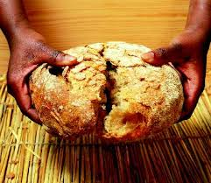

The purpose of making bread (both physically and metaphorically!) is to enjoy sharing and eating it together. In this final week of reflections we take our thinking and pondering out into daily practical action. Offer each days suggested action to God as an intentional act of prayerful reflection.

‘While they were eating, Jesus took bread, and when he had given thanks, he broke it and gave it to his disciples, saying, “Take and eat; this is my body.” ’
Matthew 26:26

Monday

Broken: As you eat your bread together as a family, in the action of breaking, slicing or tearing the bread remember and pray for families across the world or known to you personally who are broken or torn apart in any way by the present circumstances.

Tuesday

Giving thanks: Before you eat your evening meal today give thanks to God for his presence and provision. If appropriate begin a ‘gratitude journal’ as a family and take it in turns to record one thing for which you are grateful each day as you eat together.

Wednesday

Sharing: If you are able to sit down to your evening meal together with members of your family. Switch off all devices and share the time and meal intentionally.

Thursday

If you have enjoyed baking bread make a loaf and give it to a friend or neighbour. Alternatively you might share some flowers from your garden or another small gift with someone who is on their own just now. Another way to share might be to send someone a card to say you are thinking of them or share a family zoom meeting with another family you haven’t been able to see.

Friday

Share with a friend one thing you have rediscovered and one new thing you have learnt during lockdown and also one way they might pray for you.

Weekend

Read back though these reflections and find one practice or insight that you wish to take forward. How might you practically ‘taste the benefits’ of this practice and insight? The following might be ways to take your intention into practice:

- share your intention with a trusted friend or spiritual director for some support or accountability
- write a note to remind yourself of this truth or practice and pin it up in the kitchen or bathroom or bedside table
- ask for help with household jobs or child care so that you can have some regular time to ‘rest and rise’ in prayer and time with God. Find a small way to do the same for your partner or a friend.

‘While they were eating, Jesus took bread, and when he had given thanks, he broke it and gave it to his disciples, saying, “Take and eat; this is my body.” ‘
Matthew 26:26

Exalted Manna, gladness of the best

All that we need
waits for us
in the earth at our feet
we need only bow the knee each day
to pick it up.

So take and eat
feeding faith
until it walks the way of trust.
Gather this manna,
bending the knee
to touch the earth
a genuflection of gratitude

And on the seventh day
make sure you come to rest
ark-like
under this arc
of promised provision.

For on this day
we offer the best
of the goodness we have collected
not hoarding or storing
but gladly giving thanks.

And on this day
we lift our bread
and breaking it in two
we dare to share
and share
until all are fed.

