Researching your audience & branding

- Who is your target audience?
Look at the specifics - demographic, gender, lifestyle, hobbies, behaviours etc.

- Do you have a Mission Statement?
This should sum up in a few lines what your goal is.

- Research others
Look at your “competitors” (other churches). Use the spreadsheet below to note the messages, visuals, quality, reviews and mentions, marketing efforts etc.

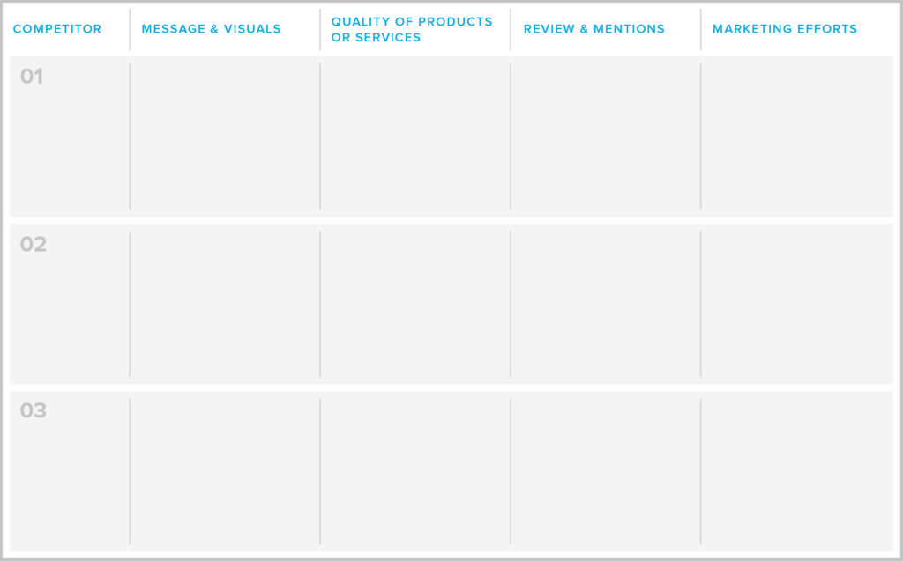

- Outline key qualities and benefits you offer that the others don’t.
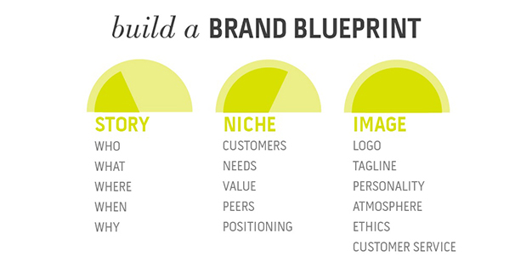
- Do you have a logo/ tagline?
Does it support your answers to the above questions?

- Your Brand voice
How you communicate needs to be relevant for each audience. Looking at your answers above, how are you communicating?

- Brand message and elevator pitch
You’ve got one chance to speak to someone. In 1-2 sentences spell out your brand message, your quick grab ‘elevator pitch’.

- Brand Personality
Experience tailored to audiences’ needs, backed by genuine personal interaction = brand personality

- Brand should be visible in everything the customer sees, reads, hears.

- Consistency
Be consistent in what you show people, how you speak to people. You are aiming to build trust. People need and like to know what to expect.

- Be its biggest advocate

