Short Branding Exercise

This exercise has four phases:

- Brainstorm possible values and attributes for your brand
- Separate those into what belongs and doesn’t belong to it
- Group the ones which belong into abstracted groups
- Distil them into values, key attributes and analogies

You should be able to get a better idea by simply doing the above but if you require more information, read on.
Every brand stakeholder should take part, so if your team fits in a room, get them of all in there. If it’s larger, get the people who’d be expressing the brand day-to-day. You can also bring whoever demonstrates interest — you want motivated people brainstorming. Don’t do this by yourself.
Once you’ve listed the participants, schedule a 90-minute block for the first session in a room with whiteboards or foam boards. Get plenty of colourful sticky-notes (at least 40 per person) and Sharpies for everyone. Don’t use fine point pens so ideas can later be read from a distance. Snacks could be handy too.

1. Brainstorming Attributes
For starters, keep in mind (and reinforce with the group) the basic rules of brainstorming: there are no bad ideas, and be additive to other’s ideas. Set a timer for 10 minutes to instil some urgency.
Start writing out random adjectives on stickies, words (simple, exclusive) or short expressions (gender neutral, on your terms) which could be used to describe your brand. As people write down each idea, they should say it out loud and place the sticky on the table, so others can hear it. This lets participants build on each other’s ideas.
People will be tempted to stick to “good” adjectives — like smart, professional, etc. Those can be acceptable, but also tend to be generic, which isn’t helpful in differentiating a brand. So try to include controversial or even silly ideas, just to get the discussion going. A few of my favourites are complex, hard, expensive, aggressive, powerful, for dummies, rough. They often cause people to write down the opposing notion — or something in between , which leads to interesting discussions later on.
Throughout this brainstorm, make sure to keep people generative and on topic — no discussion about what works or doesn’t should happen yet.
After about 10 minutes, ideas might start slowing down. If not, do another 10-minute round. Avoid stopping until after 2 minutes have gone by with no new ideas (the silence can be helpful sometimes).

2. Yeses and Nos
Next, write on opposite sides of the whiteboard, the words Yes and No. As a group, go take every single sticky note and agree on where it should go. Yes means “this word could be used to describe our brand”, and no means, uh, no.
The discussions which happen during this step are the most important part of the process. There will be plenty of disagreement, which is healthy, but which needs to be sorted out. Some stickies might actually start on one side and move to the other (that’s why we’re using them!). When you hit a wall, try to deconstruct the meaning of the word in question.
A few tactics to try:
- Try to find a close synonym. Sometimes a specific word carries implicit meaning to some people, and replacing it with an equivalent can filter it out.
- Use an antonym. If it’s clear the opposite of the original word belongs under yes or no, then it’s easier to place the original.
- Separate the brand from the product.
- Separate the brand from the audience.
- Skip it and come back to it later. A word you discuss later might clarify the disagreement about the current one.
This process will take quite some time, and you should use all the remaining time in this session to finish this sorting. A few disagreements might remain unresolved, and that’s OK (up to about 5 or 6 adjectives — if you have a large “maybe” group, you probably haven’t gotten to the bottom of it).
You should be exhausted at this point, so call it a day. Document your board (photos are great, transcribing each word is ideal) and feel free take down all the stickies, but keep yes and no separate!

3. Surfacing Patterns
For the second session, bring the yes stickies from before. This should also take 90 minutes, but it’s often done in less time.
This step is about organizing ideas in groups of emerging patterns, a process also known as clustering or affinity mapping. To get started, spread out all the yes stickies on a table.
Start picking stickies at random, and placing them on the board, grouping related adjectives close to each other. This might feel awkward in the beginning, but after 3 to 5 minutes the team will start to spot similarities, and tight groupings will emerge. You will probably see groups like these three:
Presentation. Visual ideas about style, color, light, polish, etc.
Tone. Communication-related adjectives such as voice, authoritativeness, friendliness, etc.
Personality. Human-like attributes, such as being expert-like, teacher-like, childlike, etc.
As well as other groups, mainly about values: abstract, almost philosophical notions — transparent, affordable, innovative, etc. These will probably be unique to your company’s mission or offering.
Try to organize all stickies on the board in up to 60 minutes. As groups become clear, write a descriptive name for it on the board (or on a different color sticky), above the adjectives. Once you’re done, your board should look somewhat like this, and you’ll be ready for the last step.
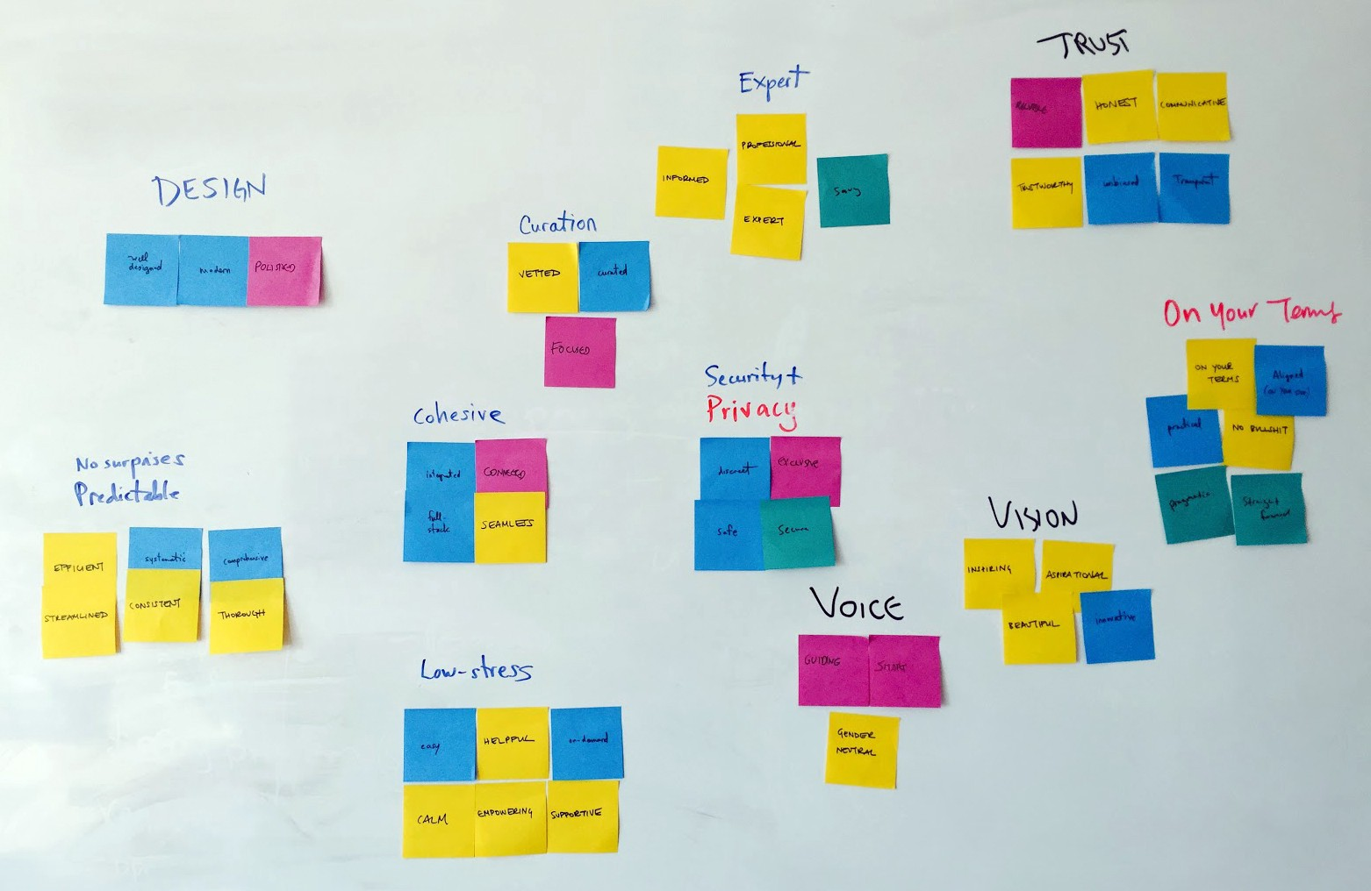

What your affinity map board might end up looking like. Note the different handwriting above each group: everyone is participating.

4. Distilling into Values
This is the last step, and the most analytical. Going through each of the groupings, transpose them to a hierarchical list in a text document, including titles and content. You can work off this template if you want. Example:

Visual
Clean, Bright, Colourful, Handmade etc

Tone
Funny, Colloquial, Deferent etc
If any of the groups doesn’t feel unique to your brand, ignore it. If it seems to be about abstract values, put it under a Values header, with all adjectives in a single line. Then, with the team, try to sum up what that group of values encompasses. Example:
Values
Safe, Secure, Trustworthy → Secure
Easy, Empowering, Low Barrier to Entry → Easy
Then take another pass at the resulting list and, try to coalesce each group further. Aim to limit each header to 4 items, to ensure the result is actionable.
These attributes by themselves can still be a bit ambiguous. That’s when brand comparisons can be helpful.
Use the remaining 10 minutes of your session to add to the document a “Brand Comparisons” header. Under it, list at least 10 sentences using the format “More like ___ than ___”. You should fill in the blanks with other brands. But brands in the broadest sense possible: well known public entities about which there’s consistent perception between people. They should ideally not be in your industry, and can include celebrities, cities, typical dishes, etc. This part usually leads to fun discussions. Examples:

More like Google than Apple
More like Toyota than BMW
More like Tag Heuer than Swatch
More like Sketch than Photoshop
More like George Clooney than Ryan Gosling
More like burgers than sushi

Try to get at least 15 of these; 30 if possible.
And that’s the end of the exercise, you should have now a document which outlines your brand values, shows concrete ways those values present themselves, and anchors your brand relative to others in different spaces.

Conclusion
You could work with a branding agency for a richer — and more expensive — process, which could achieve more granular results. But you have little time and money to spend, and this will get you what you need to start establishing a brand.

Bruno Bergher, Medium

