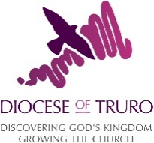

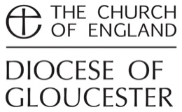
Photographic and Filming Consent form

This form should be completed when photographs or videos are being taken which may be used for marketing purposes. (Please note that photographs at public events for editorial purposes do not require consent).

Name: _____________________________________________________

Email (or contact address):_____________________________________________

The Diocese of Truro would like to take a photograph or a video of you for promotional purposes. These images may appear in our printed publications, on our website, or social media accounts. Please answer questions one, two and three below, then sign and date the form where shown. Any image taken or information you provide will not be used for any other purposes.

Please note that websites can be seen throughout the world and not just in the United Kingdom, where UK law applies.

We will not include personal details such as names or ages without obtaining further consent.

Please circle your answer

- May we use your image in printed materials
such as newsletters and booklets? Yes/No

- May we use your image on our website? Yes/No

- May we use your image on Diocese of Truro Yes/No
Social media (Facebook, Instagram and Twitter)

- May we use your image(s) in our press releases to Yes/ No
media outlets

Signature(s): _______________________________________

Date: __________________

You can grant consent to all the purposes; one of the purposes or none of the purposes. Where you do not grant consent we will not use the photo or film for that purpose. You can find out more about how we use personal data from our ‘Privacy Notice’ which is available from our website. You can withdraw or change your consent at any time by contacting the Diocese of Truro on info@truro.anglican.org.

For use by Diocesan staff only

Location of photograph:
Date:

