Our top five tips to develop an effective
church digital strategy

Local churches frequently get in touch to ask about how they should approach preparing a church digital strategy. Here are my top five tips on how to approach this:

- Focus on the ‘why’
Why are you or your church keen to share a project or campaign? It might be something the PCC (Parochial Church Council) has identified as a priority in the mission action plan, such as more outreach work with families, the foodbank you’re opening or how you’re encouraging people into your church at Christmas.
As a small team, we focus on doing several major projects well rather than lots of things badly! This really helps us to manage the resources we have and achieve maximum impact in our support for local churches. I would advise you do the same, so identify three to four areas you want to do well over the course of the year. Think about who is available to help make this happen.

- Who do you want to reach and engage with?
As part of the process of identifying the projects or campaigns, reflect on the audiences you wish to reach. The below is based on research we did with 2,000 Christians and non-Christians in 2017 – see more here. We use this chart to ensure that what we’re proposing will reach our audiences and to check that we have a broad range of materials planned for the months ahead.
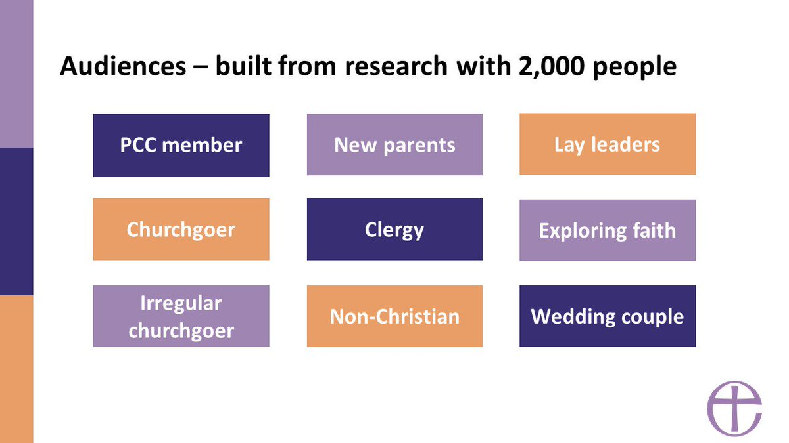

- How you share the content or campaign
What content are you going to produce? It might be a series of photos taken on an iPhone (see more in this blog from Tallie on photography) that tells the story of the foodbank, how it’s impacting the lives of those using it, how those involved are living out their faith and how others can get involved.
Remember that digital is just one of the ways in which you can make people aware of the campaign, project or initiative. Campaigns work best when you use other channels, so church newsletters, local newspapers and announcements in church really help to amplify reach.
You don’t have to worry about creating lots of content yourself, we post prayers and other resources regularly that you can share or re-tweet to keep your social media profiles fresh. You can see more on our Facebook, Twitter and Instagram pages. As this blog from Amaris in the team mentions, Facebook is the main channel we think you should use and Instagram if you have time and resource. It’s also worth following the Archbishops on social media, as well as your diocese. Many regularly share content that will be relevant to your area.

- Measure impact and success
There are great free analytics tools built into Facebook, Instagram and Twitter that help you to measure impact and reach. Google Analytics is also brilliant, and we use this across the Church’s national websites.

- Apply insights to future campaigns and projects
The best thing about looking at analytics is that it gives guides and trends on what has worked well, and what could be improved on for the next time. We do this with all of our campaigns.
Finally, ask the congregation and those who have been involved for their views. All of this will really help as you look ahead.
This is very much an introduction and we’ll be publishing more Labs Learning blogs in the months ahead.

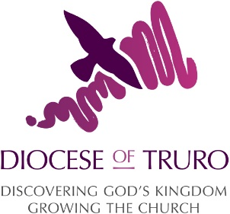
Adrian Harris is Head of Digital at the Church of England

