Over the past year, the Instagram Stories feature has become more important than the Instagram feed to those looking to strengthen their relationship with their followers and reach a younger audience.
If you’re new to Instagram, read our introduction to the platform here.

What is Instagram Stories?
The stories feature is a place where you can post photos and short videos that stay visible for 24 hours. You can find stories from those you follow through the circular feed above the grid on the Instagram feed.

Why should your church use it?
Creating content for Instagram stories enables you to post real-time updates throughout the day, giving your community behind the scenes access, and with additional features like question stickers and polls generating conversation, it has become a place where we can build a stronger connection with our community. As Instagram is about quality over quantity, stories also allow you to share your less-than-perfect images, which you might not want to post of your grid!

Getting started with Instagram Stories

1. Take a photo or record a video (See image below)
Go to the camera icon on the top left of your Instagram feed. Your camera will open.
- Press the circular button at the bottom of the screen once to take a photo.
- Press and hold the circular button to record a 15-second video.
- Add extra features like a text caption or gif sticker (see below).
- When ready press the ‘Your story’ button to send to your story feed.

2. Share a photo or video from your camera roll
If you’ve already taken a photo or recorded a video and would like to share it as an Instagram story, go to the camera icon on the top left of your Instagram feed.
- Press the photo image on the bottom left of your screen. Your photos folder will open.
- Select a photo or video.
- Add extra features like a text caption or gif sticker (see below).
- When ready press the ‘Your story’ button to send to your story feed.

3. Start a live video
- Go to the camera icon on the top left of your Instagram feed.
- Scroll along the options on the bottom of the screen, from ‘Normal’ to ‘Live’.
- When you are ready press ‘Go live’.
- Your followers will receive a notification that you are live on Instagram.
- Use it for special announcements, or to stream live from an event.
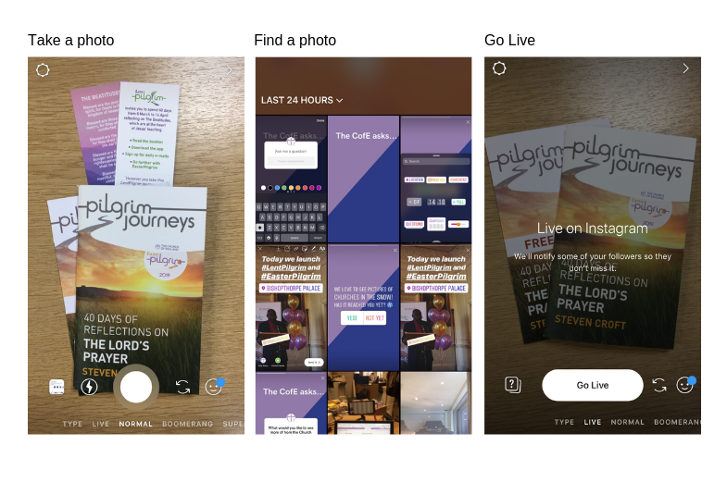

4. Add features to your story
These features are all found in the icons at the top of your screen once you have selected a photo or video.
- Text
Click the text icon to write a short caption for your photo or video.
- Drawing
Use the text icon to select your pen. Change and thickness and colours using the options at the bottom and left-hand side. You might like to highlight something on your image, for example.
- Filters
Add a filter to your picture or video by swiping your finger left across your screen.
- Gifs
Gifs and stickers are a great way to add personality to your story. After choosing a photo or video select the ‘Sticker’ icon top right of your screen.
Sticker > search a topic > select the gif > drag it into position or resize.
- Hashtags
Add a hashtag so your story can appear in searches I.e. #FollowTheStar
Sticker > hashtag > type your hashtag > move into position or resize.
- Location tags
Adding a location tag to your picture helps those watching your story see where you are, and those in the area to see your post. If you’re sharing a photo or video from your church, remember to use this.
Sticker > location > type your location > drag it into position or resize so that it doesn’t obscure the picture.
- Questions and polls
Ask a question and get instant feedback from your audience or use a poll to let them choose to between two options. Keep your questions short and punchy! You might like to ask them about events they’d like your church to run, their favourite refreshments for after the service or even what hymn to sing that Sunday!
Sticker > Question / Poll > edit the question by tapping ‘Ask me a question’ so that the text greys out and you’re able to add your own > drag into position or resize.
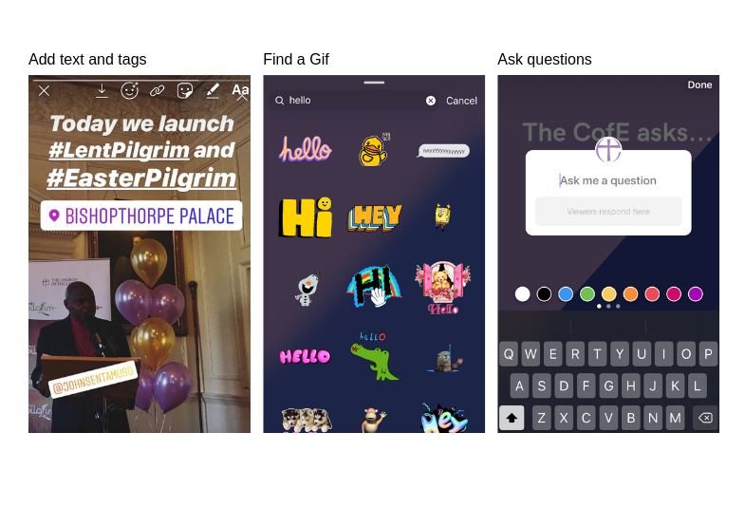

5. Sharing your story
You can share your story as a direct message with one user, with a group of ‘close friends’ or as a story on your feed for anyone to see.

6. Save Instagram stories into saved Highlights on your profile
Stories can be saved into ‘Highlights’ which appear under your profile picture on your profile page. Highlights do not expire, but you can delete them at any time. You can add as many stories to your highlights as you like, and they are a brilliant way to keep highlights from an event or important story visible on your profile for new visitors to see.
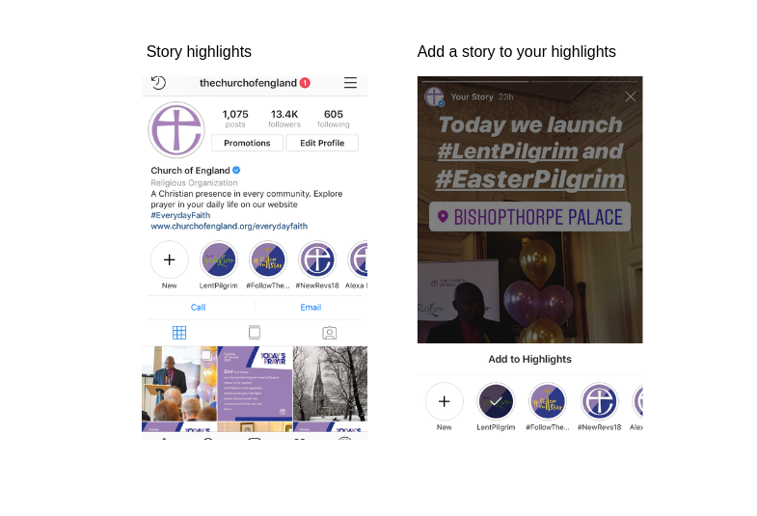

Tips
- Stories can be shared on their own as a singular post, or as a collection of stories with a linking narrative to tell a deeper story to your audience. Always keep your audience in mind by asking what kind of stories would interest them or start a discussion?
- While experimenting is fun, take time to find a tone that suits your personality and remember less is more, so stick to two or three features on your story at one time.
- Use your stories to ask questions to get to know your audience.
- Put a hashtag and location tag on every story to help those in your community see your post.
- Most importantly, give it a go! There are many more features we have not covered here, so take time in trying out the different tools. It’s best to try out these features on your own account first, and then try it from your church’s account once you have had a go. Instagram stories are designed to be fun, and ‘uncut’ so try out the features and remember you can always delete it once it’s posted!
Liz Morgan, Church Digital Champion

