How to become an approved editor of a church on A Church Near You
INTRODUCTION:
Each church can have up to five editors, and each editor can edit unlimited churches.
Each editor needs their own account, which they set up themselves, and they need to request to edit each church through that account.
An existing editor/administrator of a church cannot add editors to the church, rather the potential editor should set up and account and request to edit the church(es) as per the steps below. (Scroll down this page to the section called Approval/Verification Process to find out how that request can be approved.)
AChurchNearYou does not support the sharing of accounts between editors (ie one login accessed by more than one person), rather each editor needs their own account and will need to go through the following process.
STEP ONE:
The way in which your request to edit a church is approved will depend upon a number of factors. Before you continue any further in creating an account or requesting to edit churches, please click here to read the Approval/Verification Process section of this article to find out how your request to edit a church will be approved once you create an account and request to edit a church(es). Once you've familiarised yourself with the process, come back up here and move onto Step Two and/or Three.
STEP TWO: This step is for those who don't yet have an account. If you already have an account (can log in to AChurchNearYou) skip down to step three which is below the video.
If you don't already have an account:
PART A
- Visit www.achurchnearyou.com
- Find the church you wish to edit and then select “Edit this church” from the list of tabs on the left-hand side.
- Fill in the form and register for a new account.
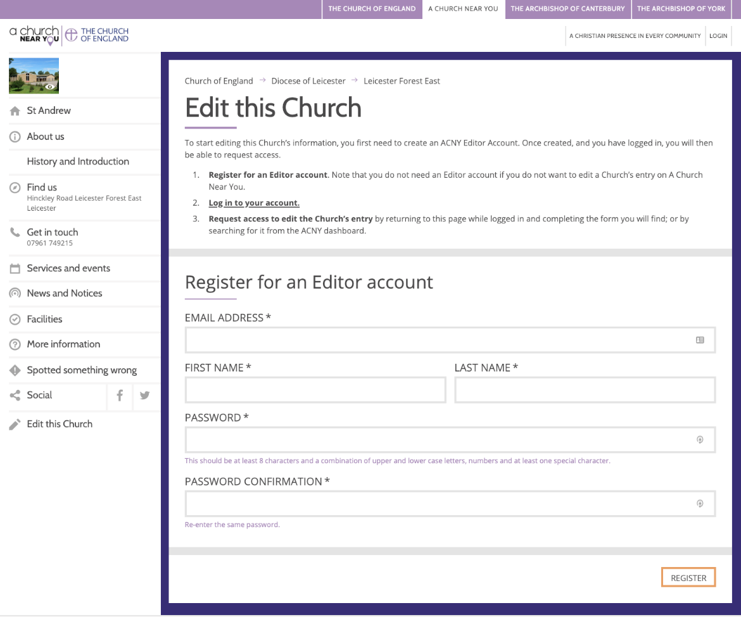
- An email will be sent to you containing a link which you'll need to click to prove you own the email address.
- Do not accidentally skip Part B! You will not be able to edit this church until you have completed Part B
PART B
- Once you've verified your email address by clicking the link which arrived by email head back to www.achurchnearyou.com and make sure you're logged in to your new account
- Search for the same church again then select “Edit this church” from the list of tabs on the left-hand side.
- Instead of the form you had to fill in last time, now you'll see one of two things. If you're the vicar who leads the church and you've fulfilled the automatic approval criteria defined in the Approval/Verification Section of this article then you'll see a message which tells you that your details have matched with your Crockford's entry and there will be a button which you'll need to click which says Claim this church. If you're not the vicar who leads this church, or you haven't fulfilled the criteria for automatic approval if you are, then you'll see a message box into which you'll need to enter a short message to your vicar and a button which you'll need to click which says REQUEST ACCESS.
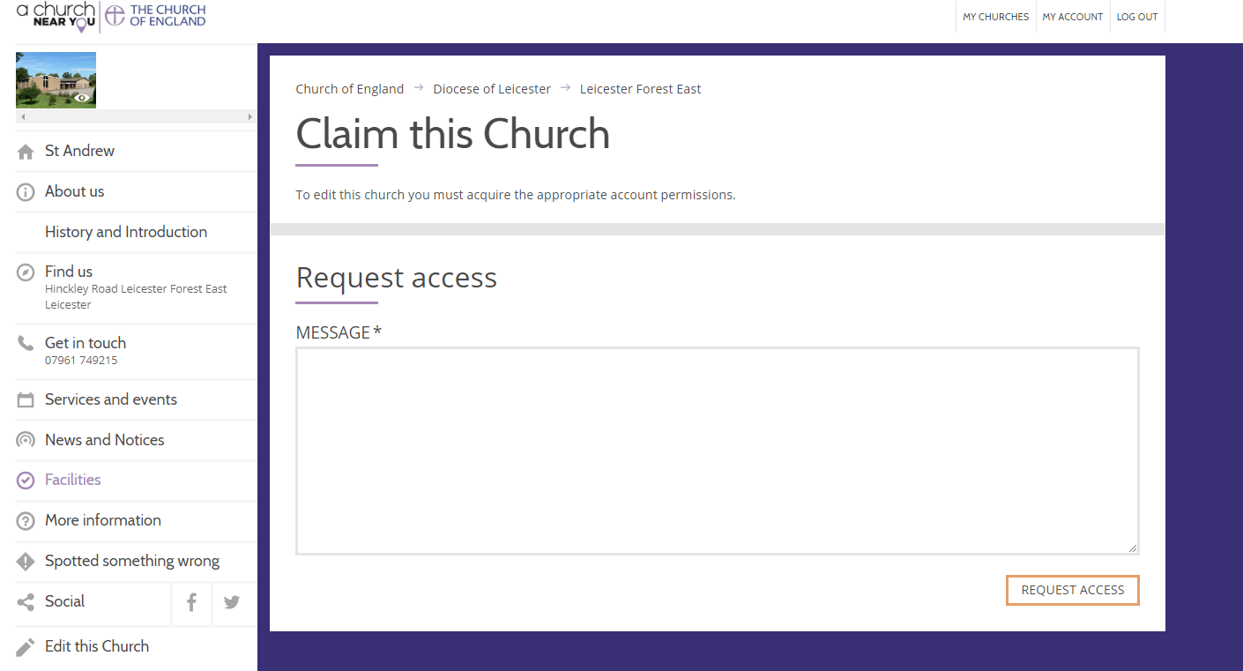
- Click the My Churches link in the top right of the screen and you'll see this church in your list.
- Your request to edit this church may have been automatically approved, or it may be pending. Approval to edit a church depends on a number of factors. Scroll down this page to the section called Approval/Verification Process and find the heading which matches your scenario.
- If you wish to request to edit further churches move on to step three.
VIDEO DEMONSTRATION (NO AUDIO)
STEP THREE: This step is for those who already have an account and want to be able to edit more churches. If you don't yet have an account (can't log in to AChurchNearYou) go back up to step two which is above the video.
If you already have an AChurchNearYou account:
- Make sure you're logged in to your account (visit www.achurchnearyou.com and click Login which you'll find in the top right of the screen).
- Find the church you wish to edit and then select “Edit this church” from the list of tabs on the left-hand side.
- (You can watch the video above for a demonstration of the steps so far)
- Click Edit This Church or Claim This Church which you'll find on the menu on the left hand side of the page.
- If you're the vicar who leads the church, and you've fulfilled the automatic approval criteria defined in the Approval/Verification Section of this article, then you'll see a message which tells you that your details have matched with your Crockford's entry and there will be a button which you'll need to click which says Claim this church. If you're not the vicar who leads this church, or you haven't fulfilled the criteria for automatic approval if you are, then you'll see a message box into which you'll need to enter a short message to your vicar and a button which you'll need to click which says REQUEST ACCESS.
- Repeat all of step three, as required, for each church you wish to edit
Once you've claimed/requested access to all the churches you need to edit:
- Click the My Churches link in the top right of the screen and you'll see all of the churches you've requested it edit listed.
- Your request to edit your church(es) may have been automatically approved, or it may be pending. Approval to edit a church depends on a number of factors. To find out how to get your request to edit approved, find the heading which matches your scenario in the Approval/Verification Process section below.
APPROVAL/VERIFICATION PROCESS
(scroll down to find the heading which matches your scenario)
SCENARIO 1) You are the vicar who leads the church:
If you are the vicar who leads a church your application to edit that church on AChurchNearYou is automatically approved so long as:
1) You have listed an email address on your Crockford’s entry and you have not requested to have your contact details restricted
2)The email address you've used for your AChurchNearYou account matches the email address on your Crockford's entry.
3) You are included on the Crockford's entry for the church(es) you're requesting to edit (if you don't have a Crockford's subscription you can check if you're listed on a church's entry by going to the church's AChurchNearYou page and clicking More Information, if you're listed under the Crockford's Contact Details section you're listed on the entry)
If you are the vicar who leads the church, and you meet the criteria above, then your request to edit the church will be automatically approved and you will also be automatically assigned administrator status for the church.
An editor with administrator status can approve or decline requests from other people to edit that church, and can remove existing editors from that church.
Only the vicar who leads the church can be the administrator.
---------------------------------------------------------
Please note: If you requested to edit a church before you fulfilled the automatic approval criteria (for instance, perhaps at the time you requested to edit a church your email address on your AChurchNearYou account didn't match the email address on your Crockford's account) your request will be held as pending and will not be automatically be approved. In this scenario, please update either the email address on your AChurchNearYou account or on your Crockford's entry so they match and ensure you've fulfilled the other required criteria. Your request to edit will still not be automatically approved, instead you'll need to contact Support in order to request Manual Approval: scroll down to the heading: If you require a manual approval for any other reason which is further down in this article and follow the instructions there.
---------------------------------------------------------
HOW TO UPDATE THE EMAIL ADDRESS ON YOUR CROCKFORD'S ENTRY OR THE EMAIL ADDRESS ON YOUR ACHURCHNEARYOU ACCOUNT:
If you need to update either your contact details on AChurchNearYou or your Crockford's entry please follow the instructions at: https://achurchnearyou.zendesk.com/hc/en-us/articles/360002336113
Please note: You do not need a Crockford's subscription to find out what is listed on your own entry or to update your own entry. You can update your Crockford's entry at any time.
Once Crockford's have accepted the update, it can take up to one month for the update to appear on AChurchNearYou.com; the data is not passed live from one to the other, rather batch updates are sent to AChurchNearYou from Crockford's on a regular monthly basis.
If you require access to edit a church more urgently than this timescale will allow, we'll need to perform a manual approval. Scroll down to the heading: SCENARIO 4) You require a manual approval for any other reason which is further down in this article and follow the instructions there.
In a small number of cases, due to some Crockford's settings, curates also become administrators when they apply to edit a church.
SCENARIO 2) You are not the vicar who leads the church:
Unless your church is in vacancy, the vicar who leads your church needs to approve your application.
If they don’t have an account they’ll need to create one, and request to edit their church as described in the steps at the top of this page.
Once they're able to edit the church they'll be able to click Manage Editors and then click Pending Requests. From there they can approve your request, even if they haven’t received an approval request email for you to edit the church.
This article explains how the vicar who leads a church can approve requests to edit their church: https://achurchnearyou.zendesk.com/hc/en-us/articles/360003569093
SCENARIO 3) Your church is in vacancy:
If your church is in vacancy you’ll need to ask us to perform a manual approval; once you have created an account on AChurchNearYou.com and have requested to edit a church(Step Two, and where appropriate Step Three) make sure you’re logged in and click the purple Help button on the right hand side of any page of AChurchNearYou and click Contact us, or click the Submit a request button at the top of the Help Centre.
Please note, we may need to contact your Rural/Area Dean, Archdeacon or Diocesan staff member to verify the request before we approve it.
In your message please include the following:
- The reason you're requesting Manual Approval (ie because your church is in vacancy. Please provide as much information as possible so that the support team can understand the situation fully and provide approval as quickly as possible)
- Your email address (the one with which you registered for your AChurchNearYou account)
- Your permission for us to disclose your name, contact details, and request to your Area/Rural Dean, Archdeacon, and/or Diocesan staff to order to gain approval.
- The AChurchNearYou ID of the church(es) you have requested to edit and for which you require Manual Approval.
You'll find this ID by going to the AChurchNearYou church page in question and looking in the browser address bar where you'll see: https://www.achurchnearyou.com/church/ followed some numbers, please could you provide us with those numbers.
For instance the URL for St Alkmund's in Duffield is: https://www.achurchnearyou.com/church/13370/ so their AChurchNearYou ID is 13370.
SCENARIO 4) You require a manual approval for any other reason:
Once you have created an account on AChurchNearYou.com and have requested to edit a church (Step Two, and where appropriate Step Three) make sure you’re logged in and click the purple Help button on the right hand side of any page of AChurchNearYou and click Contact us, or click the Submit a request button at the top of the Help Centre.
Please note, we may need to contact your Rural/Area Dean, Archdeacon or a Diocesan staff member to verify the request before we approve it.
In your message please include the following:
- The reason you're requesting Manual Approval (eg you're an interim minster covering a group of churches. Please provide as much information as possible so that the support team can understand the situation fully and provide approval as quickly as possible)
- Your email address (the one with which you registered for your AChurchNearYou account)
- Your permission for us to disclose your name, contact details, and request to your Area/Rural Dean, Archdeacon, and/or Diocesan staff to order to gain approval.
- The AChurchNearYou ID of the church(es) you have requested to edit and for which you require Manual Approval.
You'll find this ID by going to the AChurchNearYou church page in question and looking in the browser address bar where you'll see: https://www.achurchnearyou.com/church/ followed some numbers, please could you provide us with those numbers.
For instance the URL for St Alkmund's in Duffield is: https://www.achurchnearyou.com/church/13370/ so their AChurchNearYou ID is 13370.

