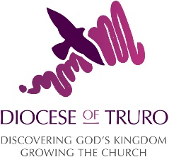
A checklist for setting up social media accounts
It’s important when first setting up an account for your church or individually on Twitter, Facebook or Instagram that you fill in the profile information as fully as possible. The more information we provide, the more helpful we are to people visiting our accounts for the first time.
Before creating social media accounts, it’s worth thinking about how you will use them.
Keep reading to find out what are the important fields to fill in:

Twitter
Profile picture: This should be your church logo. If you don’t have a logo, what not create one in Canva? Be aware that the logo will appear in a circle so make sure the logo doesn’t get cut off in the corners.
Cover picture: Choose a nice picture from a service or event showing the people that make up your church family.
Bio: You have 160 characters to explain what kind of a church you are, how do you worship? Remember to use easy to understand language.
Location: Let people know where your church is.
Website: Link to your website or A Church Near You profile to help people find out more about you.
Settings: Select suitable privacy and notification settings. If your church has capacity, we advise you to open up your private messaging inbox to all so that people can contact you through it.

Facebook
Cover and profile picture: same as above! If you have both Twitter and Facebook, try and use the same images to provide consistency.
Contact Information: On the ‘About’ page, make sure you’ve filled in as much contact information as possible, including your website or A Church Near You profile
About: This page also has About and General Information text sections to explain more about your church. Similar to your Twitter bio, think about the most important information people need to know about you (and again, use easy to understand language)
Settings: Make sure all the right settings including privacy and notifications have been set up.
User roles: This is where you choose who has access to edit the page. We strongly recommend having 2-3 administrators (users who have the ability to add/removed pages editors) this will help avoid the page becoming inaccessible by the church.
Instagram
Profile picture: This should be your church logo. Be aware that the logo will appear in a circle so make sure the logo doesn’t get cut off in the corners.
Website: Link to your website or A Church Near You profile to help people find out more about you.
Bio: You have 150 characters to explain what kind of a church you are, how do you worship? Remember to use easy to understand language.
Settings: Select suitable privacy and notification settings.

Once you have these basics filled in, you are ready to post!

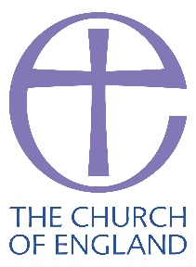
The Church of England Digital Team

