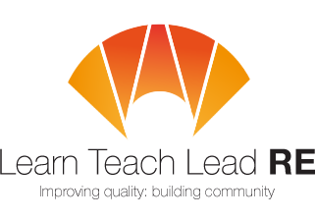
You are warmly invited to attend a joint
Mid Cornwall/West Cornwall LTLRE hub meeting
to be held on:
Wednesday 20th November from 4pm-5.30pm
Richard Lander School, Truro, TR3 6LT.

We are delighted to welcome Diocesan Education Advisor:
Ed Pawson
from Exeter Diocese, who will be leading our session on:
“How do we teach Islam in today’s society?”
This will be free cross-phase training for anyone teaching Islam in
any Key Stage.
Please pass on this invitation to RE Co-ordinators and anyone teaching Islam. Anyone that teaches RE in your school is welcome to attend.
This meeting will provide opportunities to:
- meet with your project lead teachers for RE.
- network with other schools.
- develop new ways to raise standards in RE in your school.
RSVP or for further details please contact:

Felicity Henchley felicity.henchley@celticcross.education (primary)
Helen Wells whe@bodmincollege.co.uk (secondary)

LTLRE hubs are funded through an award from St Luke’s College Foundation www.st-lukes-foundation.org.uk/
Hubs are affiliated to the National Association of Teachers of RE www.natre.org.uk/
For further details of our programme and its partners, please visit our website www.ltlre.org

