Leader’s Manual
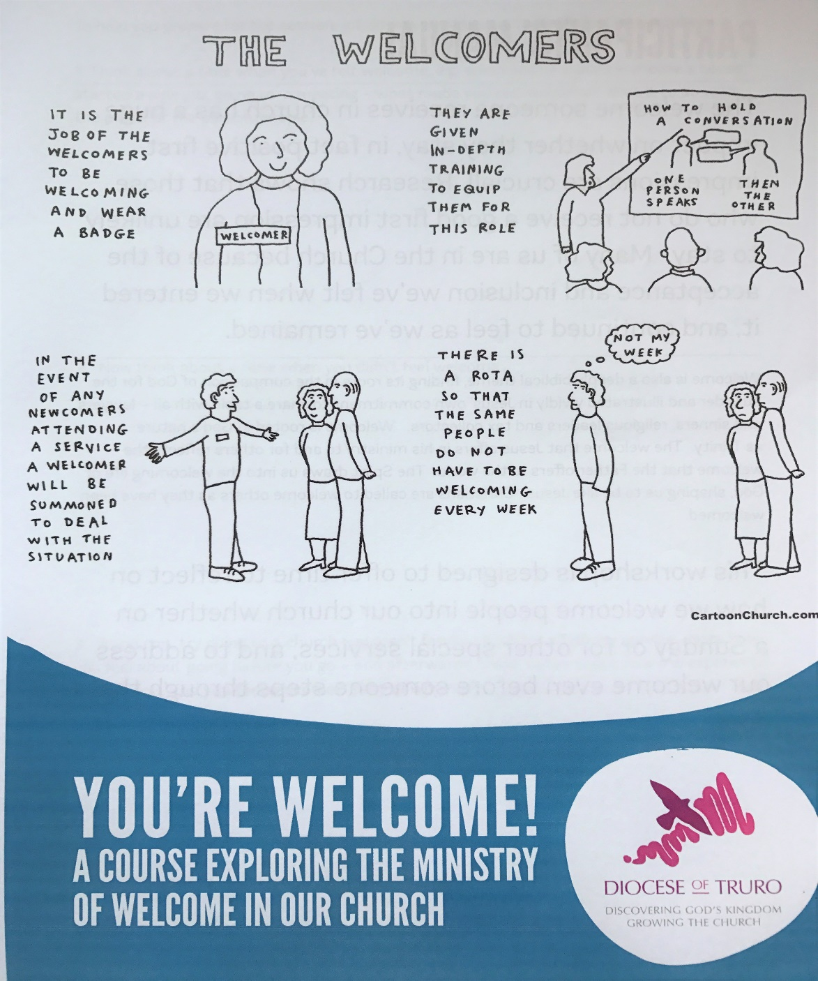
‘You’re Welcome’ is a workshop designed to help participants reflect on the experience a newcomer has when they attempt to go to a church service – will they even make it through the door?! It also explores all the elements of a good welcome in a church from the arrival to the coffee time. Research shows that the welcome someone receives in church has a huge impact on whether they stay, so positive first impressions are crucial. Welcome is also a deeply biblical theme, finding its roots in the compassion of God for the outsider and illustrated in Jesus’ own commitment to share a table with all – lawyers and sinners, religious leaders and tax collectors.

The Facilitator’s role

Thank you for being willing to lead this workshop. Your main role is to keep the group ‘on task’ as we all know of people who love to talk and go off on a tangent, and as there is a lot of material to cover, it is vital to stick to time. It’s a lot better to have time left at the end rather than to be racing to finish the work book.

There is an opportunity for pair/group work as well as having the whole group together. Please look at the powerpoint presentation in line with the paricipant’s manual and read the guidelines before the workshop so you are familiar with all the material.

Some people will expect the facilitator to have ‘the answer’. There is often no ‘right answer’ – so you do not need to feel you have to have one! More important is that you direct the group’s thinking, helping people to draw on their own experience and to learn from one another.

How long is the course?
Ideally allow 3 hours with time for tea and coffee at the start and a coffee break half way through. If only a group of 8 or less, the course can be covered in 2 hours (with no coffee half way through!)

Practicalities
  - Coffee. There should be time within the 3 hours for coffee. Some groups may prefer coffee at the start or end. If coffee is as they arrive, beware it doesn’t delay the start. Similarly, a coffee break during the session can be good, but take care that it doesn’t take too long. It might be worth taking drink orders as people arrive.
  - Set up: Depending on the numbers attending, either chairs around the screen or tables for 4 so they can still view the screen.
  - Workbooks Email liz.wallace@truro.anglican.org or phone 01872 360039 for copies
  - Bibles. Encourage participants to bring their own Bibles (or print the verses)
  - Flipchart etc. Depending on the group, you might find it helpful to use a flipchart, or to have extra pens and paper available for group work. Flipchart stands or blutack may also be required.

  - Projector and screen – the powerpoint is available on the
diocesan website and a projector and speakers are available to book and collect from Church House.
  - Sign in Sheet and name badges (or labels) – for people to fill in when they arrive. Ask for email address and church attended. It’s useful to keep for a reminder of those who have attended.

Guide to the Powerpoint
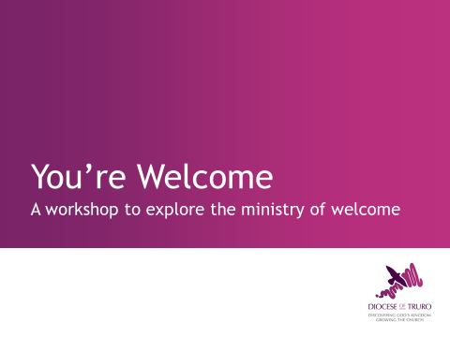

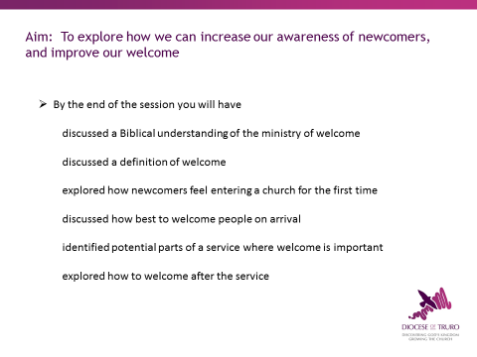
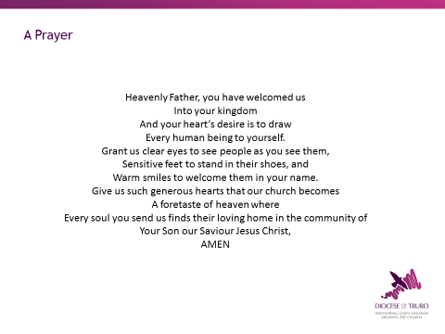
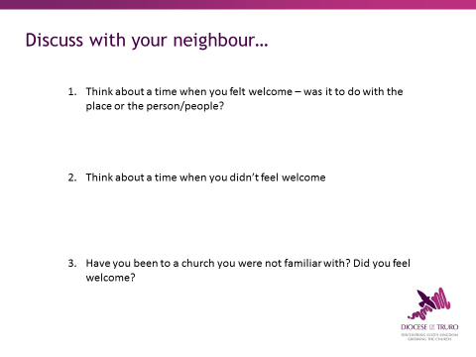

Welcome everyone. Introduce yourself as the facilitator, point out toilets, emergency exits, any refreshment breaks etc. Make sure everyone knows everyone’s name. Wearing name labels/badges is very useful both for you and for each other.

Give the background to the course…

Then start with a prayer (this is also in the back of the workbook.)

Everyone opens page 3 of the participants workbook and ask them to discuss the questions with each other and make notes.
1. For example, when you’ve visited someone’s home, a meeting somewhere. What made you feel welcome?
2. Can you explain what it was that made you feel uncomfortable and unwelcome?
3. This applies if participants received the workbook before the workshop! Otherwise they could do this at a later date, or can remember another church visit.

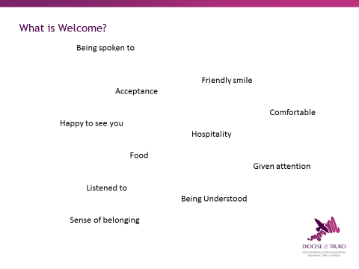
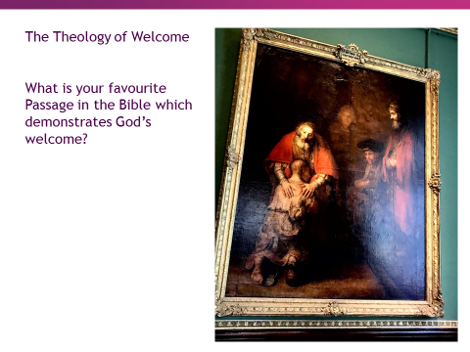
Answers:
1: The title for the section is LOVE. Point out ‘love must be sincere’ e.g. it’s not sincere if you smile and welcome in church but are rude and scowl at the local shop keeper!
2: Genesis 18:1 – angels appeared as men to Abraham and he received many favours. As we entertain people who are strangers, they can be a blessing to the host.
3: God’s people love one another. Followers of Christ will treat others with kindness, serving them as if serving Christ himself.
Introduce the video along the lines of ‘Here are some people who say what welcome means to them’. NB The sound for some people isn’t very clear but the next slide covers all the words said. After the video ask the group which words used they found particularly meaningful.

This is the list of the words used. Which ones do your church particularly relate to? Are there any your church doesn’t do well?

We’ve looked at what welcome means to us, and now we’re going to look at the Bible, and how welcome is expressed.
Turn to page 4 and 5. Ask the group to offer any Bible passages demonstrating God’s welcome. Write answers on the flipchart. Many will think of the Prodigal Son (picture on pg 7) which demonstrates God’s unconditional love, welcome and acceptance. Elaborate if you wish, but not a sermon!!
Split the group into groups of 4 and ask each one to look up ONE of these verses and answer the question with it:
1. Romans 12:9-13 Why is hospitality encouraged?
2. Hebrews 13:1-3 Why might we have ‘entertained angels’?
3. Matthew 25:34-40 What is the core message?
TURN TO PAGE 6: Ask as a group and write answers on flipchart. NB Eating is a social activity which binds us together and is a statement about belonging and acceptance.

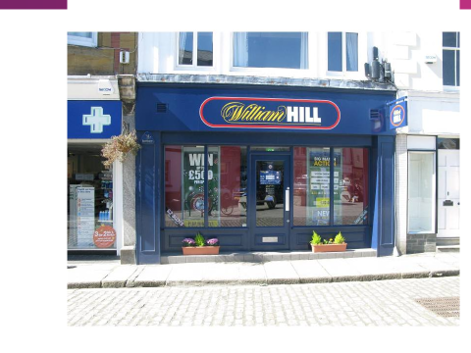

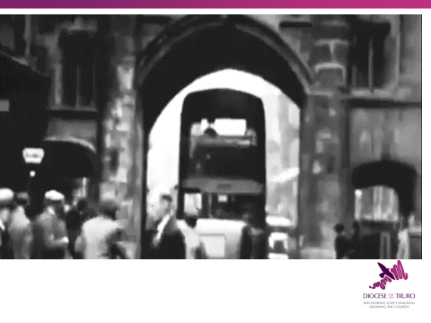

Turn to Pg 8-9
Ask someone to read the welcome on page 9. It’s from a Coventry Cathedral welcome but no one is sure where it originated. Answering the question ‘who would we find difficult to welcome unconditionally’ can take some honest soul searching, so possibly ask people to ask God to reveal to them where our judgmental nature needs addressing.

PAGE 10: Explain you’d like to encourage people to imagine what it’s like for people to come into church for the first time. Many people would not have been to a betting shop and so imagining what it’s like to go there can be a useful exercise. Ask the participants to imagine they have been given £5 with which to place a bet on a horse. How would they feel going into the betting shop? What would they want to know? Ask 2 volunteers to read out the suggestions in the form of a skit – this adds a little humour into the session!
The video adds to the humour in the form of how NOT to welcome in church in the first half, and then the how to welcome.
Follow up with PAGE 11 – what are the 20 common mistakes in welcoming visitors. Give them 5 minutes to come up with as many as they can in 2’s. They’re not all from the video. Answers can include:
1. No one said hello 2. Bad breath!
3. Personal questions e.g. are you married?
4. Too friendly (hugs) 5. No eye contact
6. No smile 7. Apathy in greeting
8. Limp handshake 9. Crushing handshake
10. B.O.! 11. Rude staring at hairstyle, tattoos!
12. Bad coffee 13. Stale biscuits
14. Unsafe toddlers/crèche area
15. Ignoring once through the door
16. Being told ‘you can’t sit there’
17. Questions about their status of faith
18. Swarming around them
19. Unclean toilets
20. Asking ‘Is this your first time here?’ (even if they’ve only been once before)
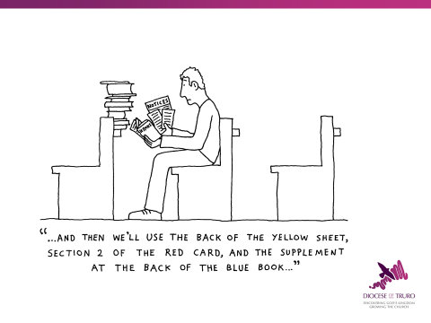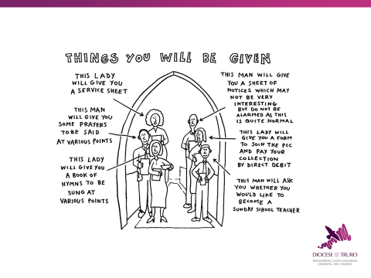

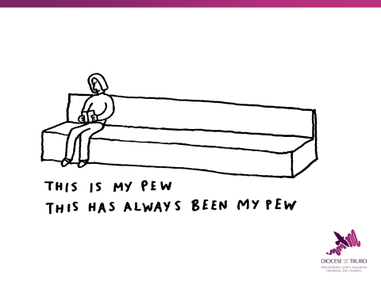
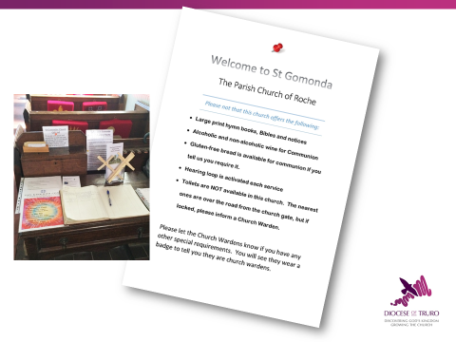
PAGE 12: We’ve said ‘Good morning’, and welcomed people through the door, but what about all the other aspects of the service. Ask the group to discuss the areas and make notes on how to help the newcomer. Allow 5 – 10 mins for this, then ask for feedback.

Books: (Both images) It helps if the service leader tells people what book/page to be on! Giving a brief explanation when given out may be helpful. Are large print copies available?

Where to sit? (image 12) Best to ask them where they would like to – some would prefer to be at the back, some would prefer to sit nearer the front where they can hear/see better. Is there another designated ‘welcomer’ they could sit with? (do they wear badges?)
Children: Inform about children’s facilities (toilets!) and Sunday school and timings. Introduce to Sunday school teacher, or someone with children a similar age.
The Toilet: where it is!

Special Needs: (Image 13) What do people need? Help getting up the steps? Dietary requirements? If they are frail or disabled would they like Communion brought to them?

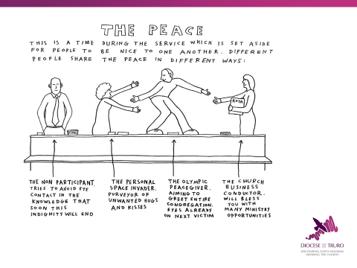

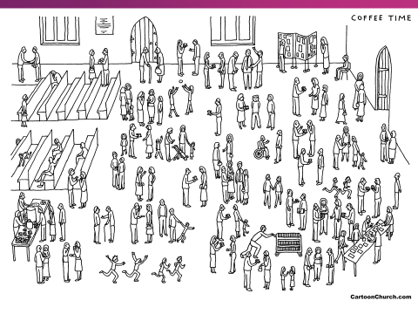

The Peace: (image 14) often a daunting experience for the newcomer. The welcome should ‘model’ this to the newcomer by sharing the Peace first with them. If the church is one where there is a 10 minute sharing of the Peace with everyone don’t leave them standing alone! Hugs are probably not appropriate!

The Collection: A good leader will explain the format in your church. Some churches say that they do not expect visitors to give.

The Communion: Newcomers should feel welcome to go up and make sure they know which way to go and whether it’s OK not to kneel etc. Are there gluten free wafers available? Or grape juice? (This may be explained by the service leader). Is it made clear that they can go up for a blessing – do they need to take a book to indicate that? (again, the leader can make that clear). If they are elderly – has someone given them the option of receiving in the pew (may need to alert someone before the service of this).

After the Service: page 13
This is as crucial as the initial welcome – will people leave with a final ‘good’ feeling. Before looking at page 13, look at the coffee time picture on the screen (or on page 14) and ask the group to circle possible people who may be feeling left out. Can you find 10?! Ask them to feedback.

Page 13: Talk through the points. Invite the participants to comment as you go through the list.
Say something to the newcomer. Don’t start chatting to a friend and ignore them. Some churches have a 3 minute rule – everyone tries to talk to someone they don’t know for the first 3 minutes!
Invite them to coffee if is being served. Take them to it and ensure they have what they need.
Introduce them to one or two others. You don’t have to stay with them - but keep an eye on them so they don’t get left standing alone.
Conversation – avoid an inquisition but do show interest in them, where they live, their interests etc. Ensure you respond with acceptance and offer appropriate follow up (do they need to see the vicar or youth worker/children’s leader)
What information can you give them? Does the church have a welcome pack? (see cartoon on back page!) Parish magazine? Details of church activities?
A card with their information – where should they leave it? Can they post it? (Where to?)
Will you recognise them if they come back? Do you make a note of their name? How can you remember a newcomer?

Page 15: Reviewing the Ministry of Welcome
Give people the opportunity to think about what needs to happen in their church as a result of what has been discussed.
1. How can the church encourage everyone to be part of the ministry of welcome? Does the church want to think about running this course again for more people?
2. Does the church have a Hospitality/Welcome Team? (not just sidespeople, although they are part of it). Appendix 3 has suggestions of what to consider.
3. Ask the group to share what they’ve learnt in the session and this will point towards future development in the church.
4. What do I think our church does a) best and b) not so well? Is a useful question to consider and share as a group if time.
5. What are we going to do or seek to change as a result of this session? Write some answers on the flipchart which can be carried forward for the future planning.

Close with thanking them for their contribution and then a prayer.

Any feedback will be much appreciated. Email: liz.wallace@truro.anglican.org
or tel: 01872 360039

